Contents

* 1. Design a simple machine learning model to train the training instances and test the same. 5
  2. Implement and demonstrate the FIND-S algorithm for finding the most specific hypothesis based on a given set of training data samples. Read the training data from a .CSV file 5

Source with output 5

Data Source TrainingData.csv 6

* 1. Perform Data Loading, Feature selection (Principal Component analysis) and Feature Scoring and Ranking. 7

b. For a given set of training data examples stored in a .CSV file, implement and demonstrate the Candidate-Elimination algorithm to output a description of the set of all hypotheses consistent with the training examples 8

Source and Output 8

3.a Write a program to implement the naïve Bayesian classifier for a sample training data set stored as a .CSV file. Compute the accuracy of the classifier, considering few test data sets.11

Source and Output 11

Data 12

b. Write a program to implement Decision Tree and Random forest with Prediction, Test Score and Confusion Matrix. 13

4a For a given set of training data examples stored in a .CSV file implement Least Square Regression algorithm. 17

4 b For a given set of training data examples stored in a .CSV file implement Logistic 20

Regression algorithm 20

5 a. Write a program to demonstrate the working of the decision tree based ID3 22

algorithm. Use an appropriate data set for building the decision tree and apply this 22

knowledge to classify a new sample. 22

5 b Write a program to implement k-Nearest Neighbour algorithm to classify the iris data set

35

6a Implement the different Distance methods (Euclidean) with Prediction, Test Score and Confusion Matrix 39

6b Implement the classification model using clustering for the following techniques with K means clustering with Prediction, Test Score and Confusion Matrix. 40

7a Implement the classification model using clustering for the following techniques with hierarchical clustering with Prediction, Test Score and Confusion Matrix 43

8a. Write a program to construct a Bayesian network considering medical data. Use this model to demonstrate the diagnosis of heart patients using standard Heart Disease Data Set 44

b. Implement the non-parametric Locally Weighted Regression algorithm in order to fit data points. Select appropriate data set for your experiment and draw graphs 45

9A. Build an Artificial Neural Network by implementing the Backpropagation algorithm and test the same using appropriate data sets. 46

9B. ASSUMING A SET OF DOCUMENTS THAT NEED TO BE CLASSIFIED, USE THE NAÏVE BAYESIAN CLASSIFIER MODEL TO PERFORM THIS TASK. BUILT-IN JAVA CLASSES/API CAN BE USED TO WRITE THE PROGRAM. CALCULATE THE ACCURACY, PRECISION, AND RECALL FOR YOUR DATA SET. 48

10A . Write a program to demonstrate the working of the decision tree based ID3 50

algorithm. Use an appropriate data set for building the decision tree and apply this 50

knowledge to classify a new sample. 50

* 1. Design a simple machine learning model to train the training instances and test the same.

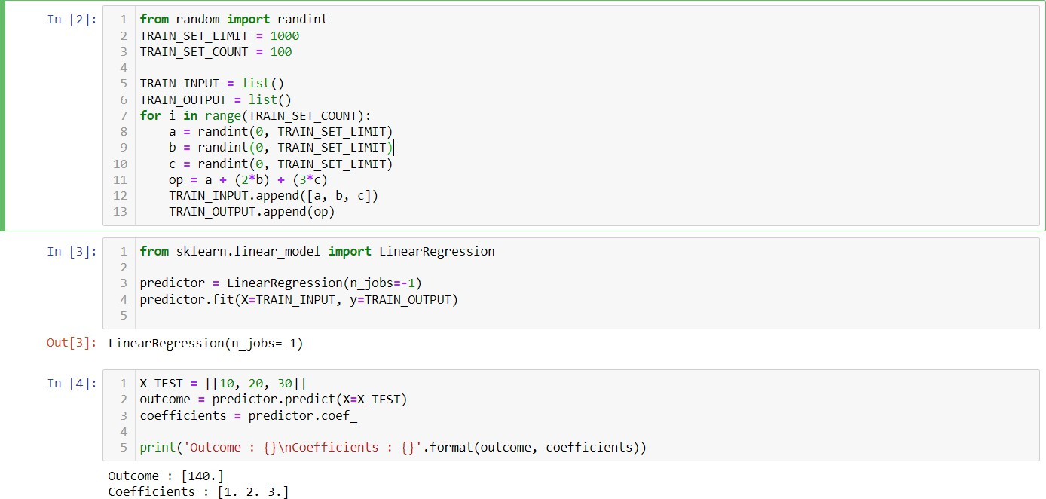

* 1. Implement and demonstrate the FIND-S algorithm for finding the most specific hypothesis based on a given set of training data samples. Read the training data from a .CSV file

Source with output

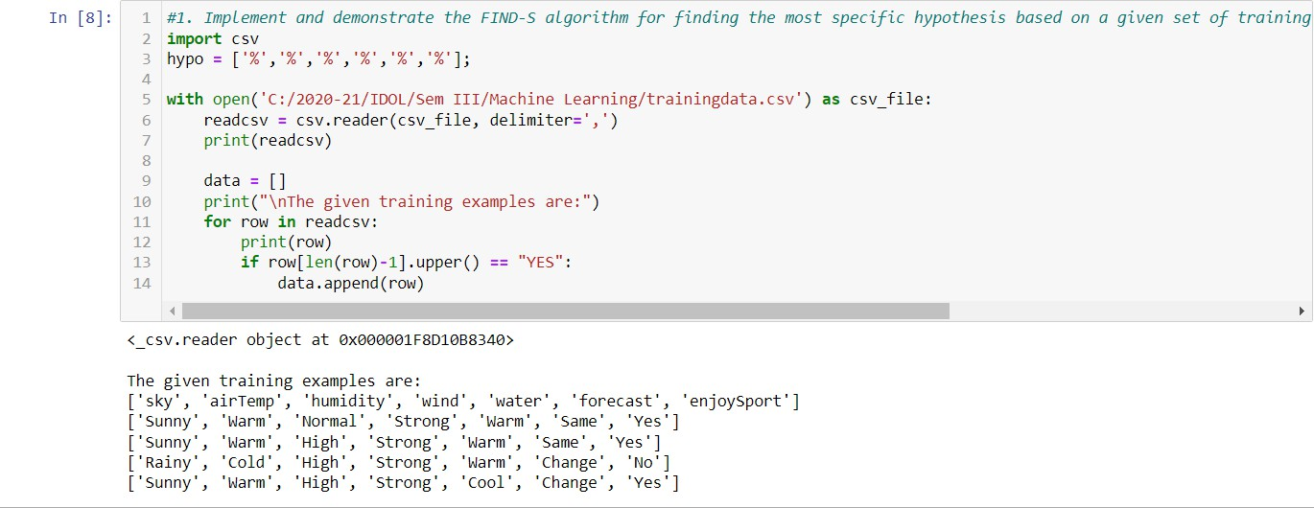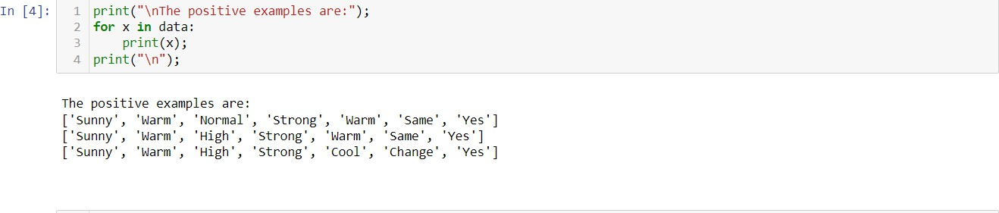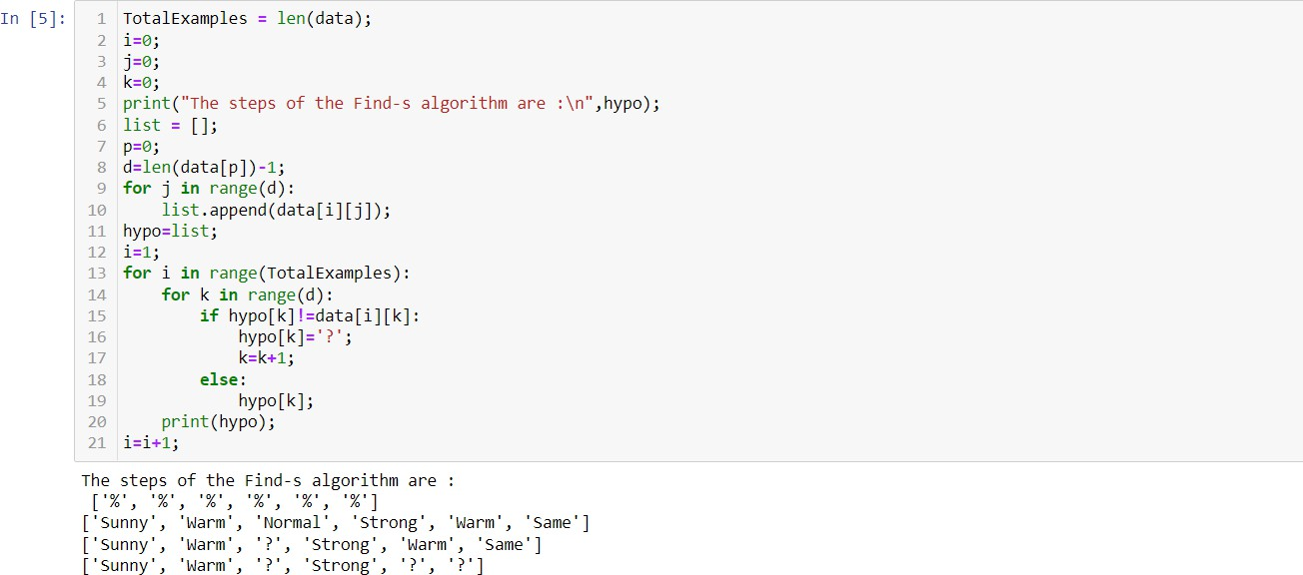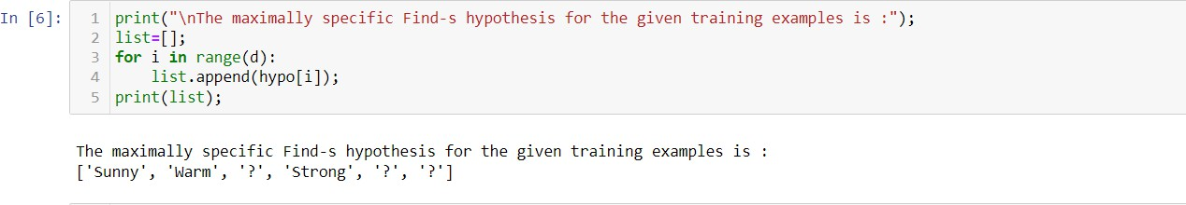

Data Source TrainingData.csv

|  |  |  |  |  |  |  |
| --- | --- | --- | --- | --- | --- | --- |
| sky | airTem  p | humidit  y | wind | water | forecas  t | enjoySpo  rt |
| Sunny | Warm | Normal | Strong | Warm | Same | Yes |
| Sunny | Warm | High | Strong | Warm | Same | Yes |
| Rainy | Cold | High | Strong | Warm | Chang  e | No |
| Sunny | Warm | High | Strong | Cool | Chang  e | Yes |

2.a.Perform Data Loading, Feature selection (Principal Component analysis) and Feature Scoring and Ranking.

* Univariate Selection.

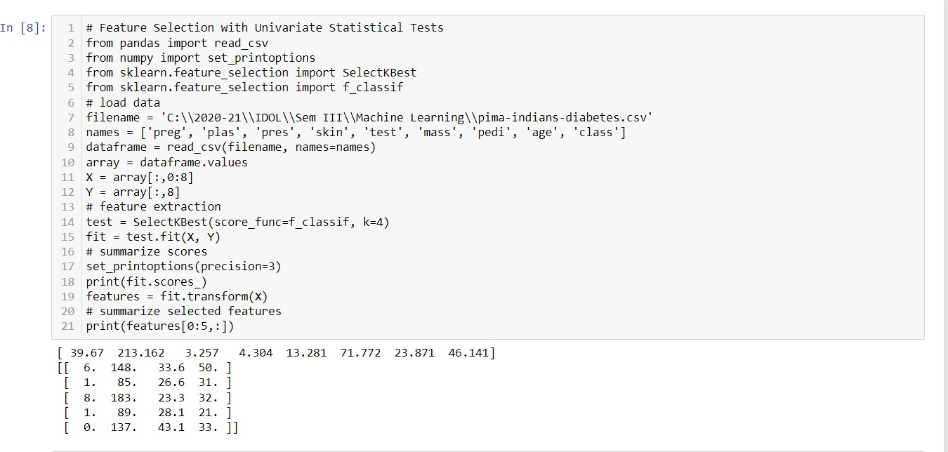

* Recursive Feature Elimination.

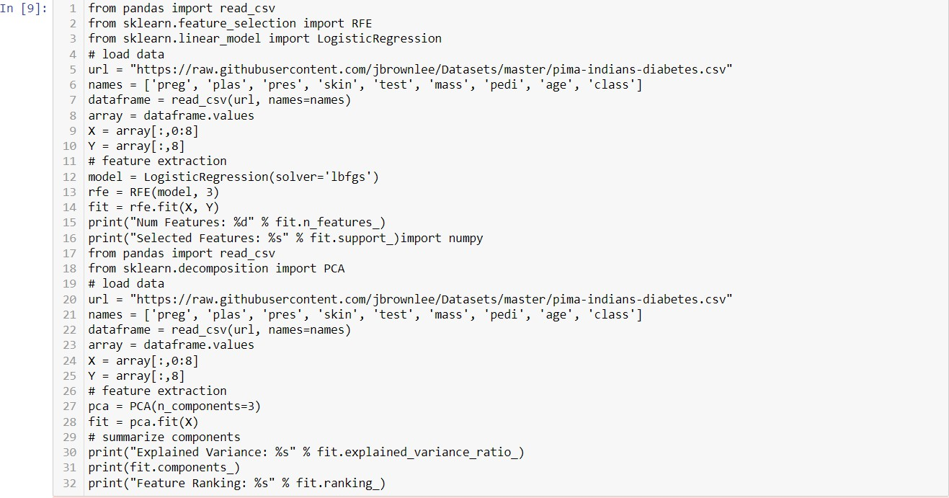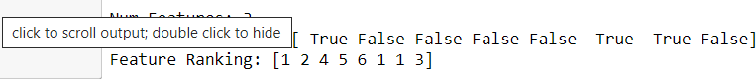

* Principle Component Analysis.

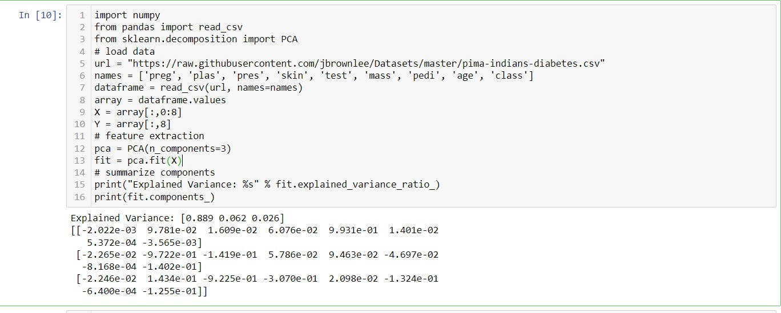

* Feature Importance.

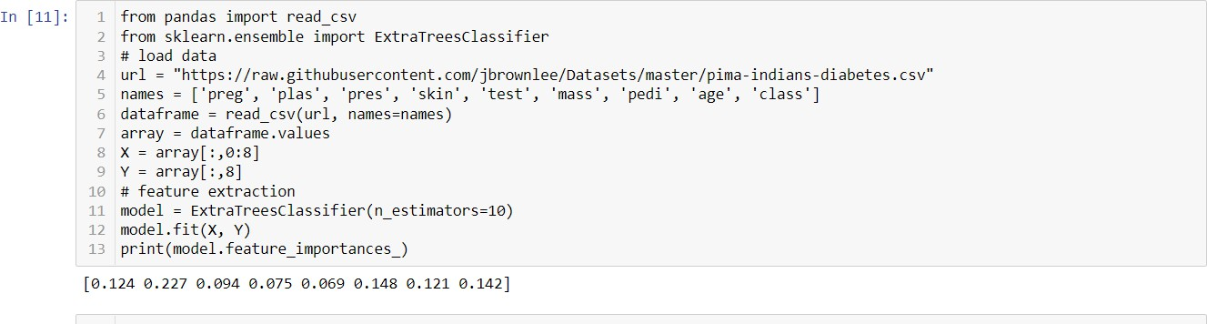

b. For a given set of training data examples stored in a .CSV file, implement and demonstrate the Candidate-Elimination algorithm to output a description of the set of all hypotheses consistent with the training examples

Source and Output

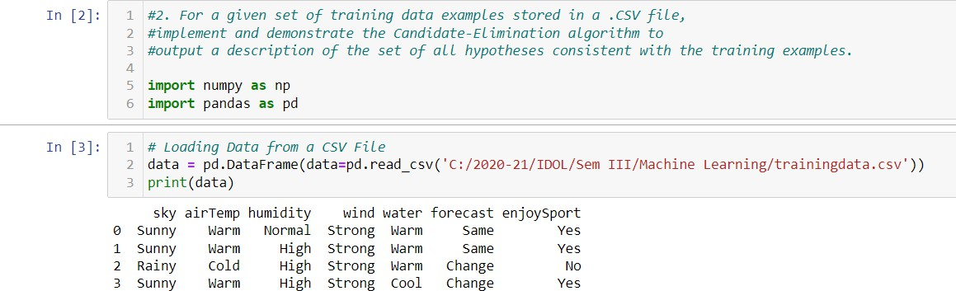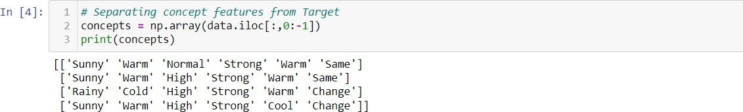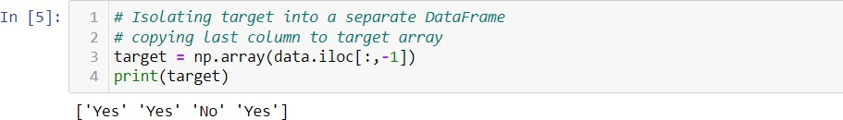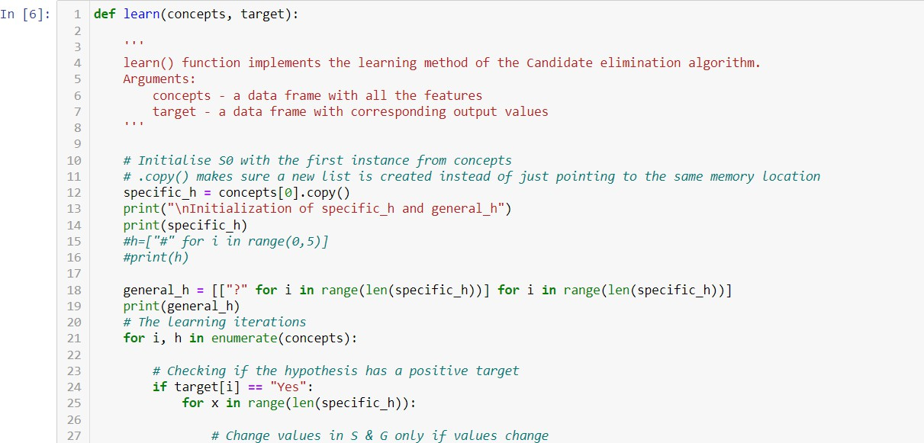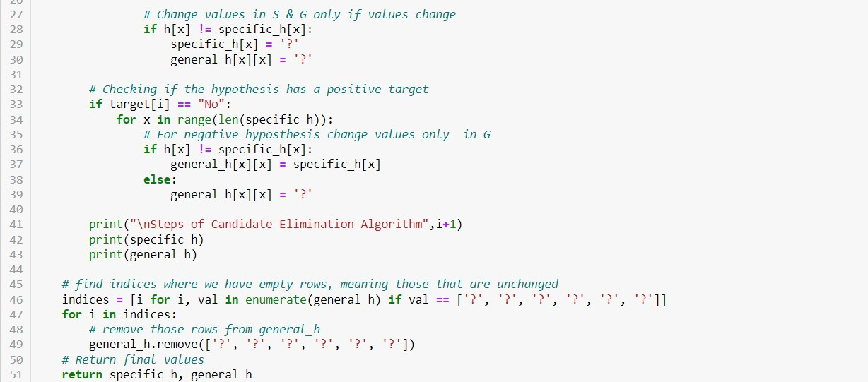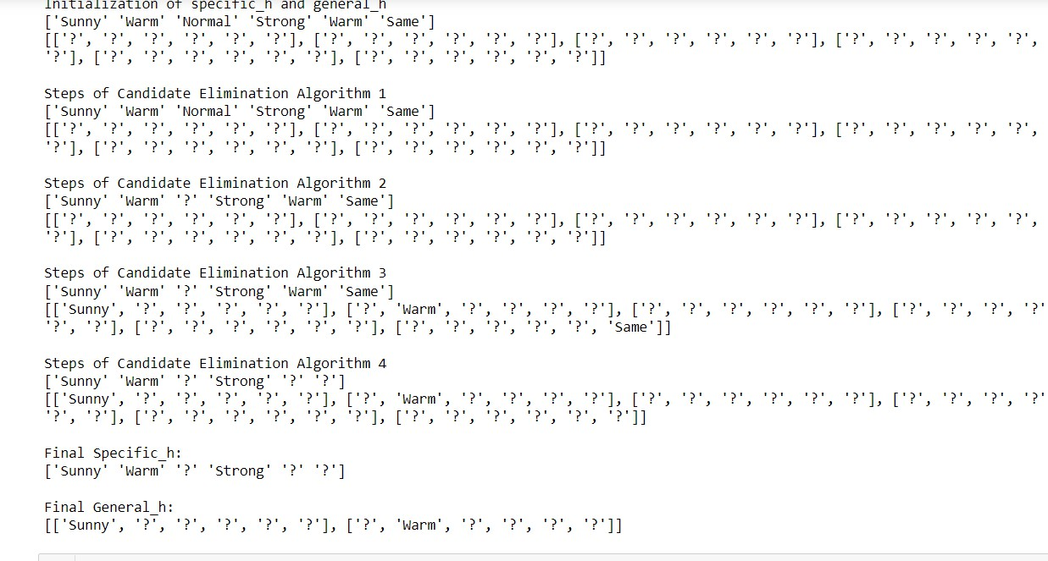

3.a Write a program to implement the naïve Bayesian classifier for a sample training data set stored as a .CSV file. Compute the accuracy of the classifier, considering few test data sets.

Source and Output

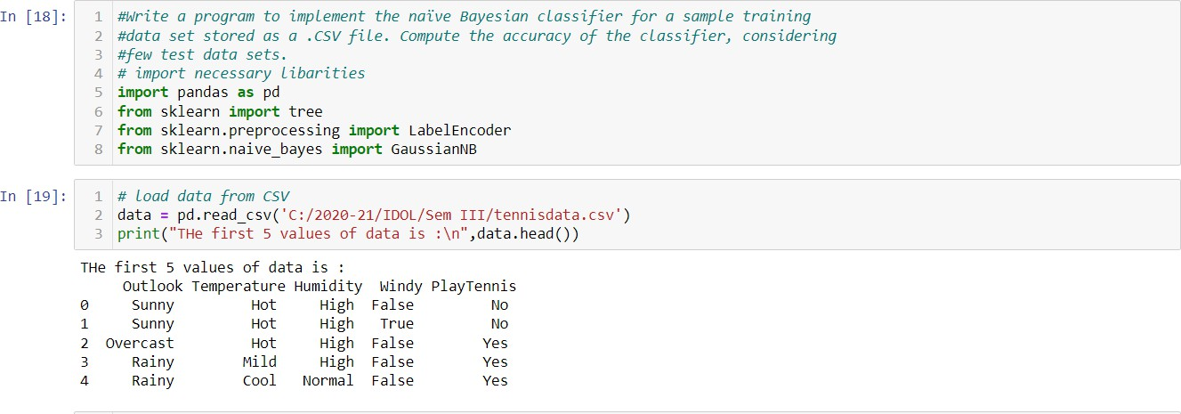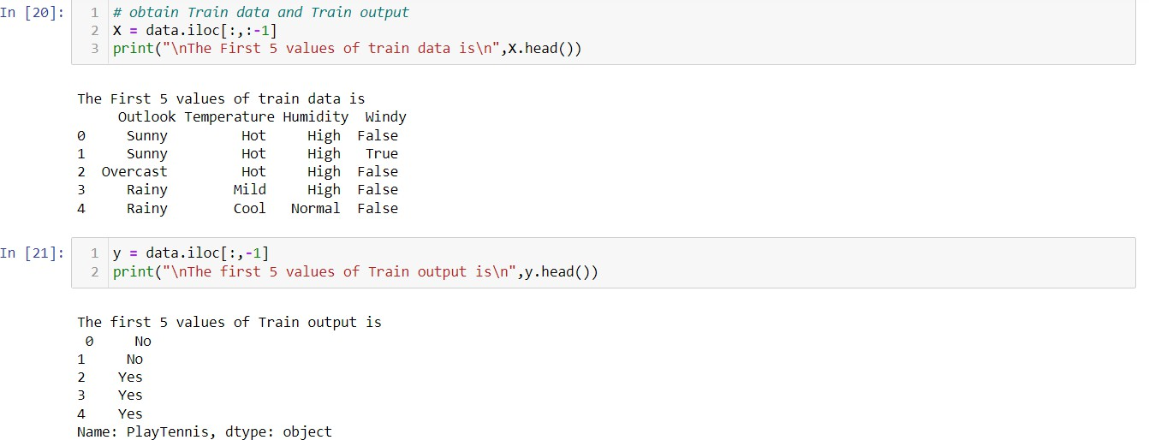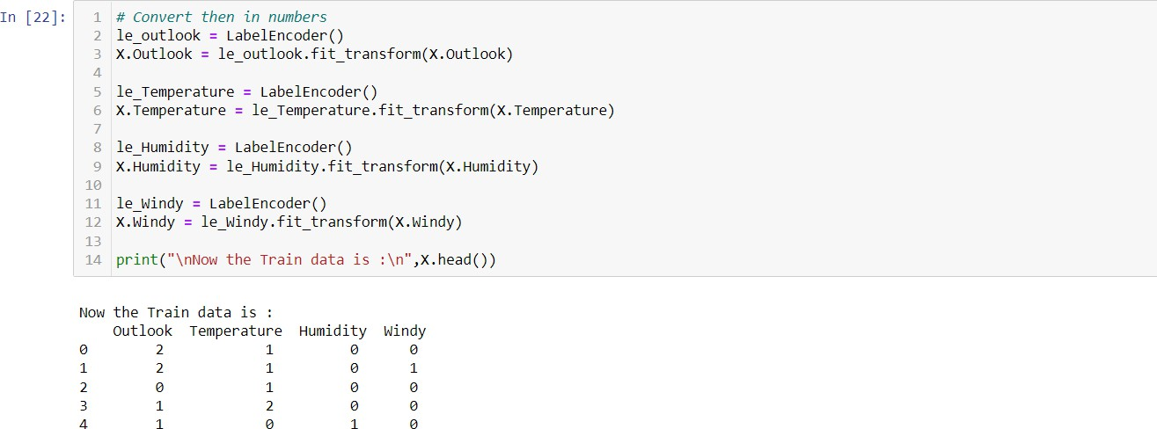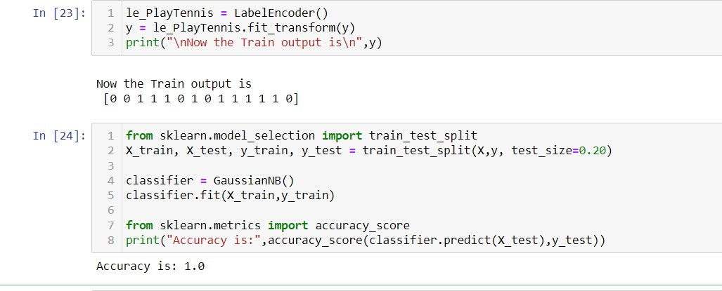

Data

|  |  |  |  |  |
| --- | --- | --- | --- | --- |
| Outloo k | Temperatur e | Humidit y | Windy FALS | PlayTenn is |
| Sunny | Hot | High | E | No |
| Sunny | Hot | High | TRUE | No |
| Overca |  |  | FALS |  |
| st | Hot | High | E | Yes |
| Rainy | Mild | High | FALS  E | Yes |
| Rainy | Cool | Normal | FALS  E | Yes |
| Rainy | Cool | Normal | TRUE | No |
| Overca  st | Cool | Normal | TRUE | Yes |
| Sunny | Mild | High | FALS  E | No |
| Sunny | Cool | Normal | FALS  E | Yes |
| Rainy | Mild | Normal | FALS  E | Yes |
| Sunny | Mild | Normal | TRUE | Yes |
| Overca  st | Mild | High | TRUE | Yes |
| Overca |  |  | FALS |  |
| st | Hot | Normal | E | Yes |
| Rainy | Mild | High | TRUE | No |

b. Write a program to implement Decision Tree and Random forest with Prediction, Test Score and Confusion Matrix.

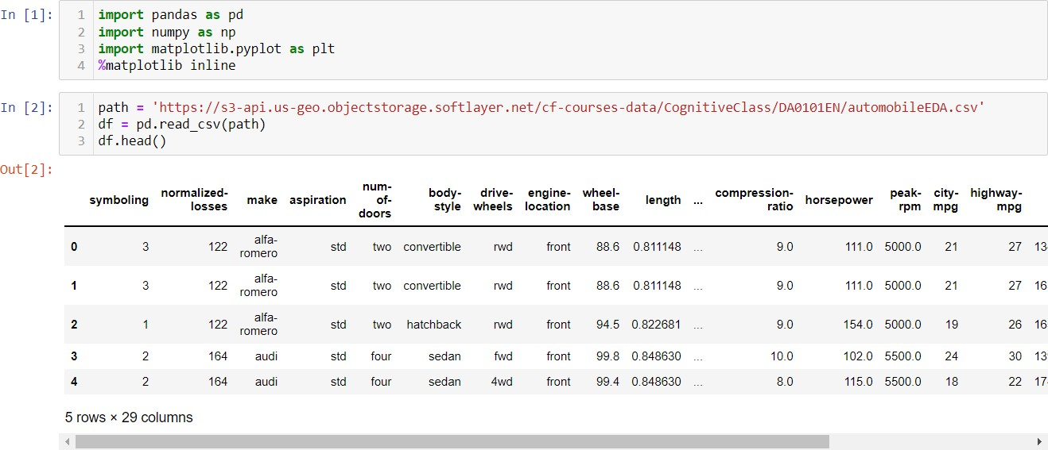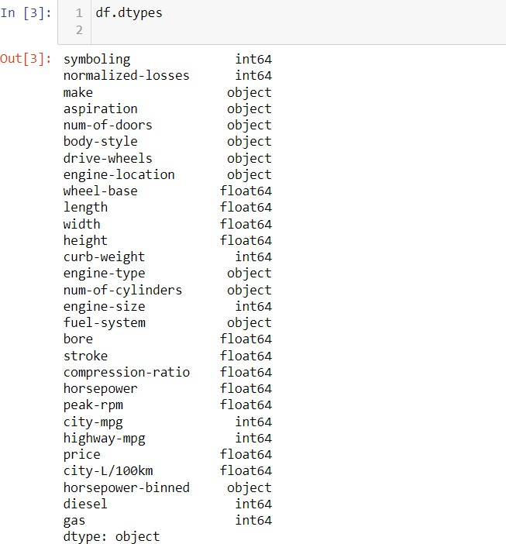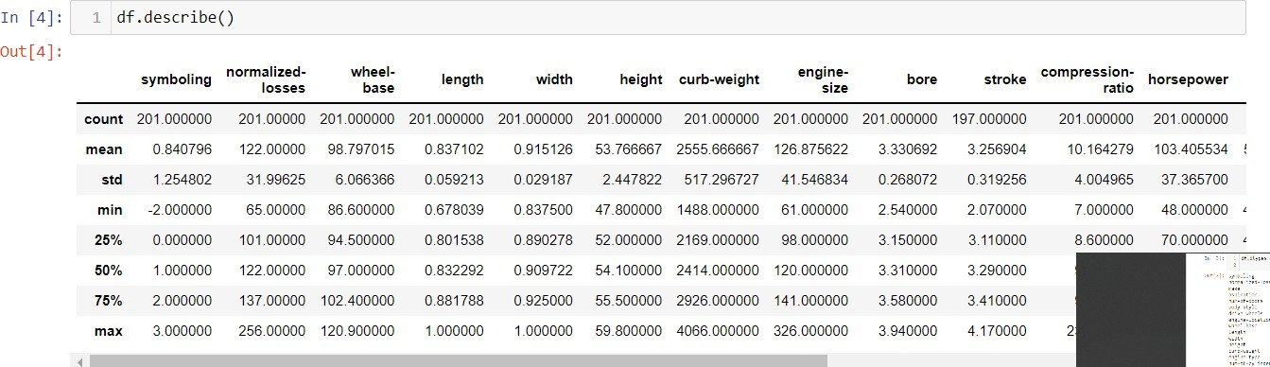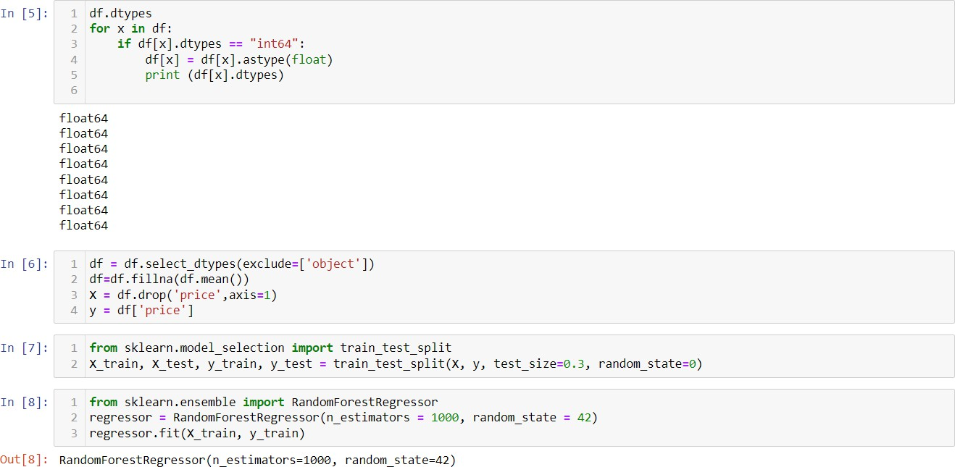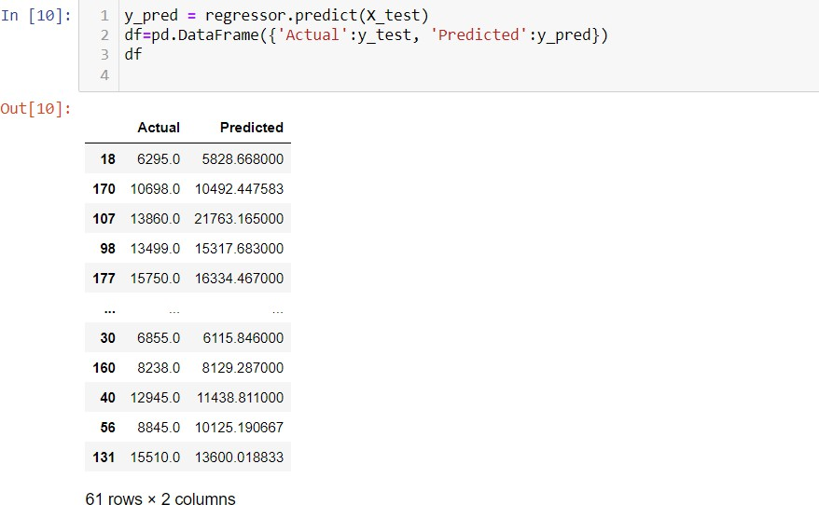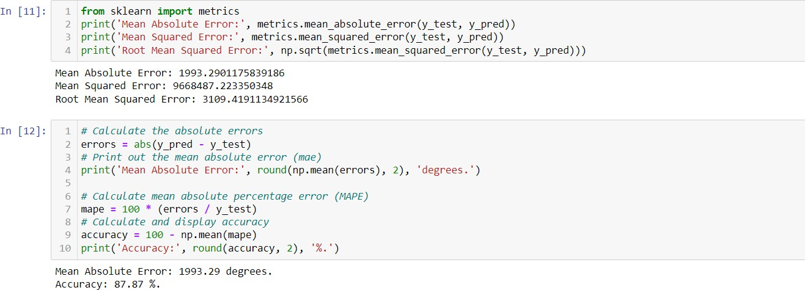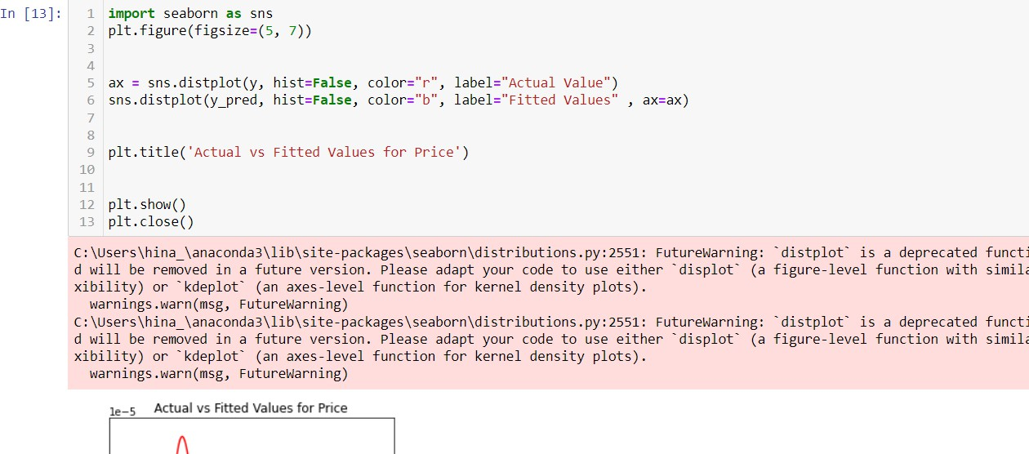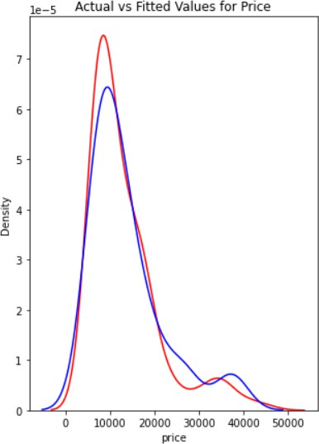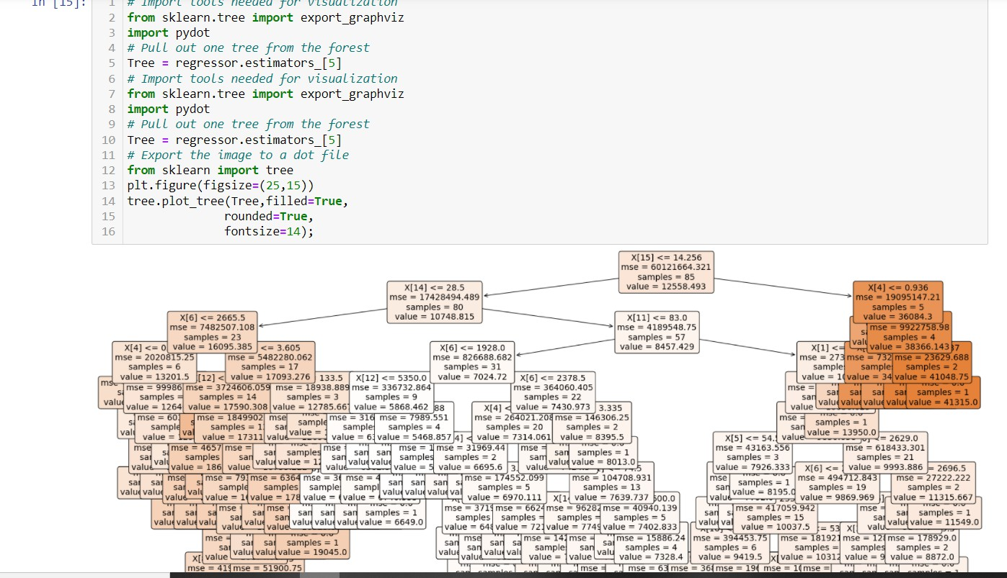

4a For a given set of training data examples stored in a .CSV file implement Least Square Regression algorithm.

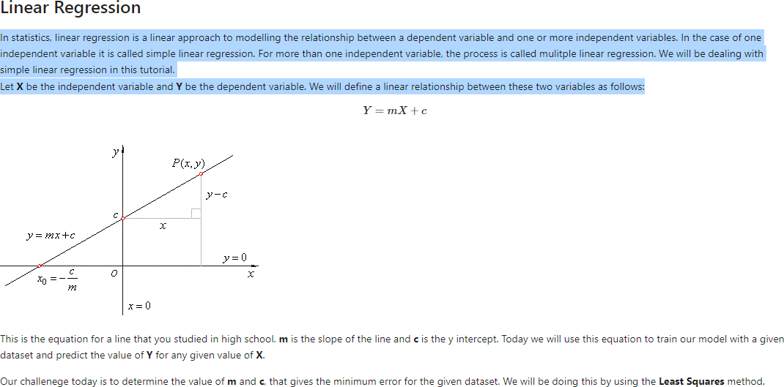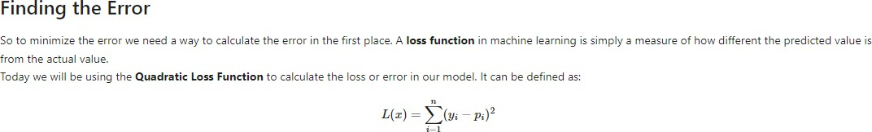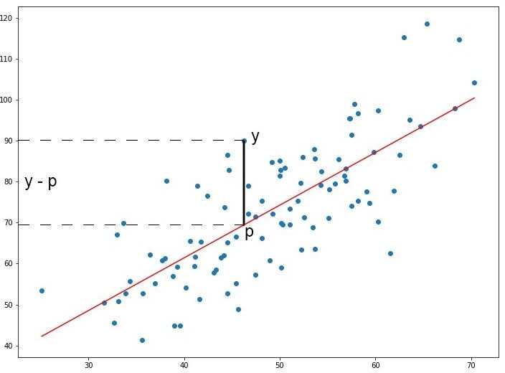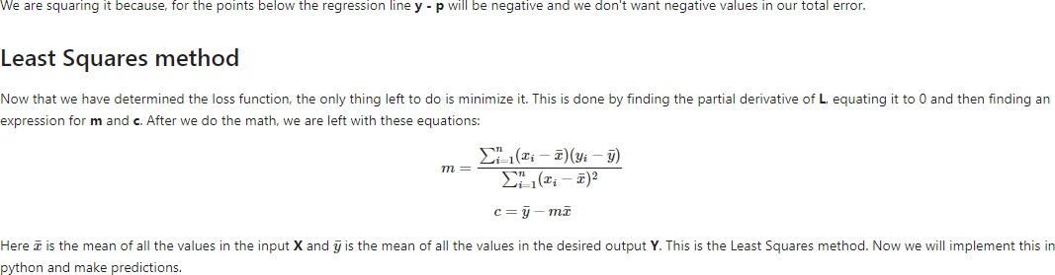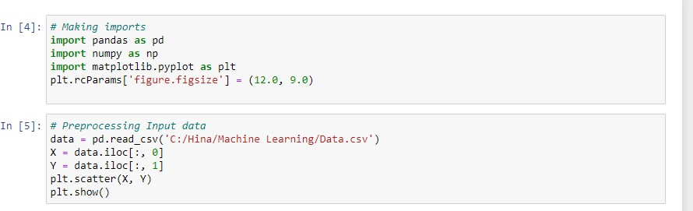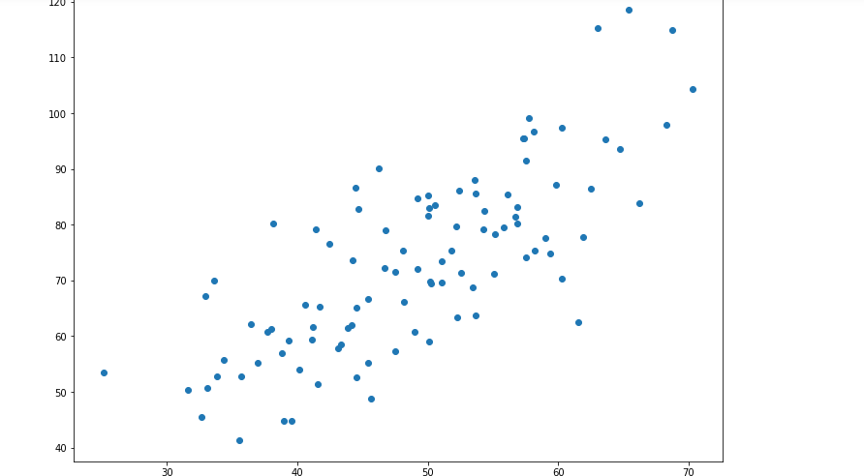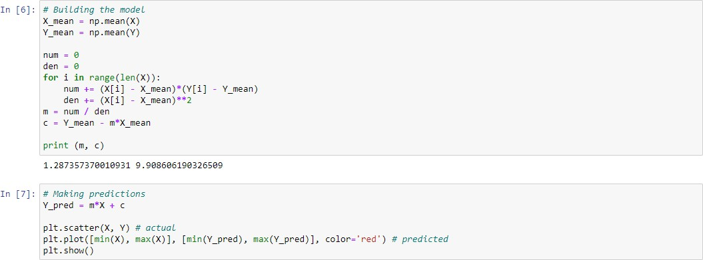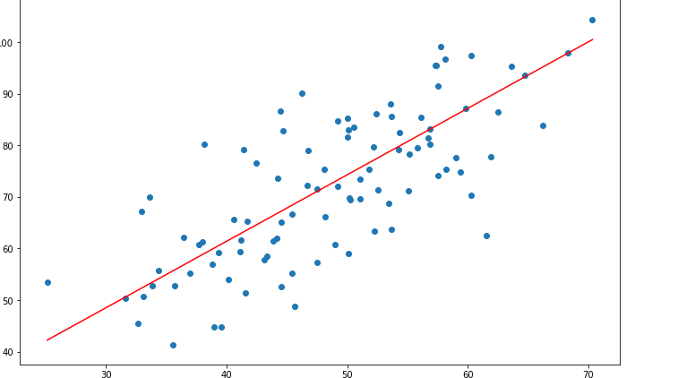

4 b For a given set of training data examples stored in a .CSV file implement Logistic Regression algorithm

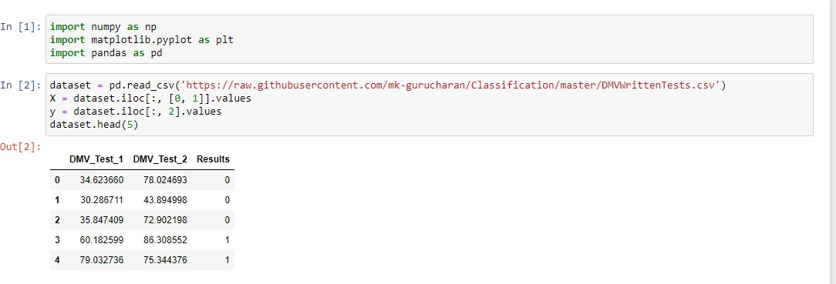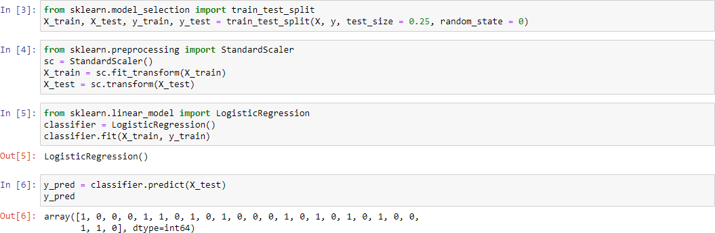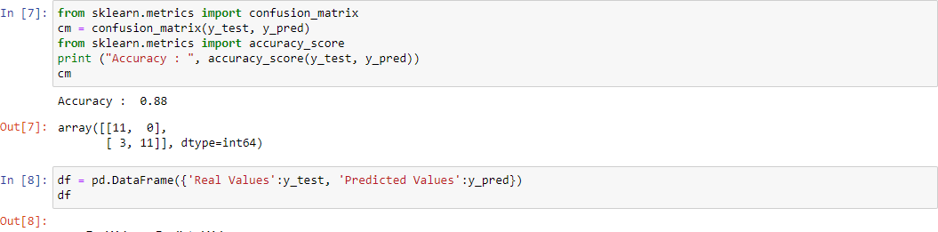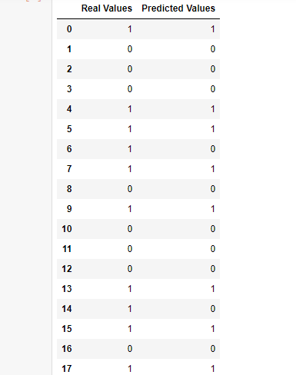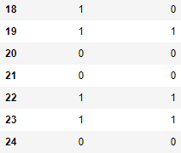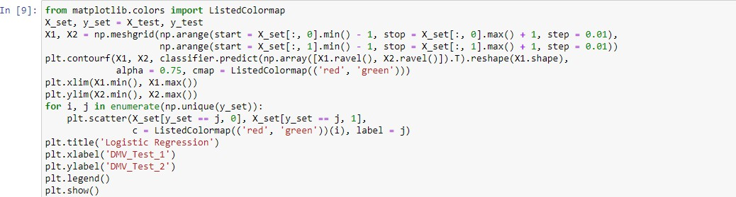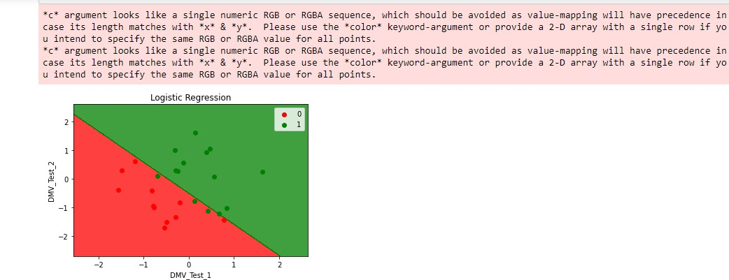

5 a. Write a program to demonstrate the working of the decision tree based ID3 algorithm. Use an appropriate data set for building the decision tree and apply this knowledge to classify a new sample.

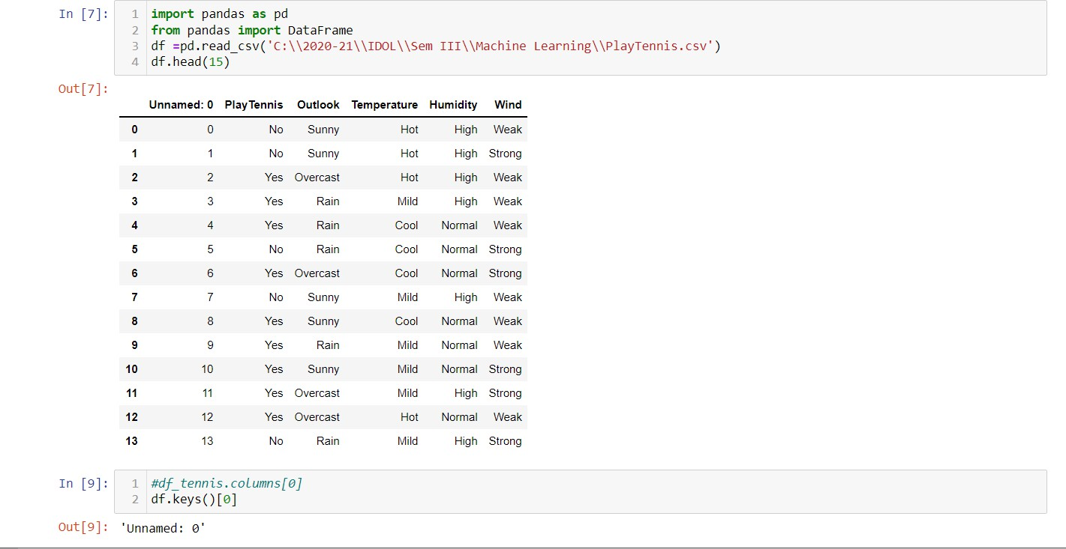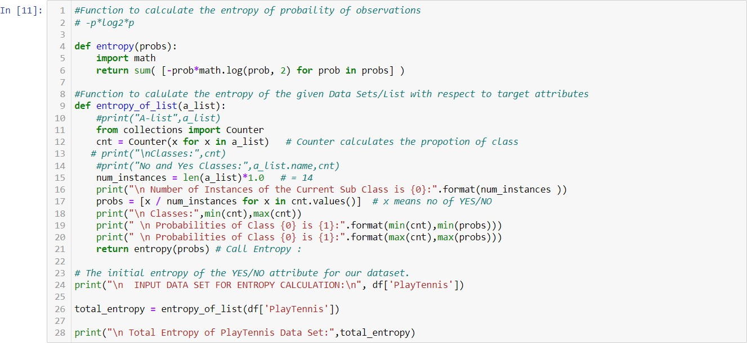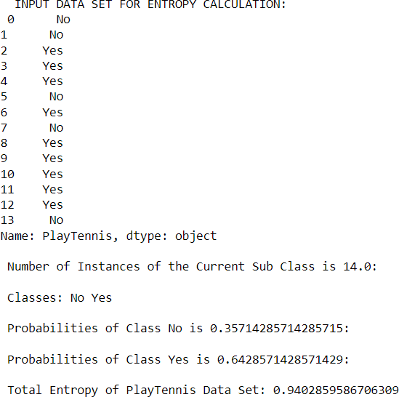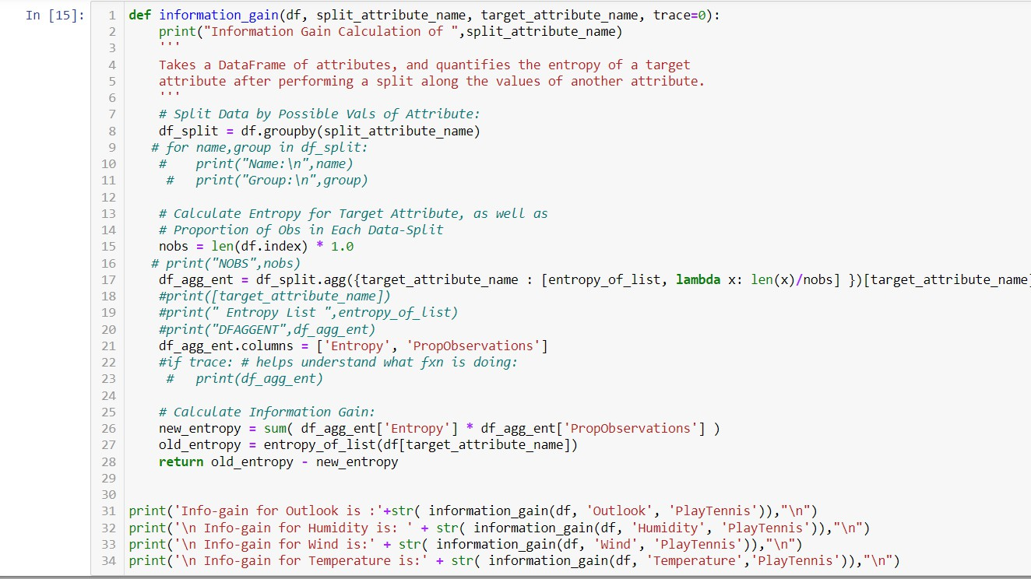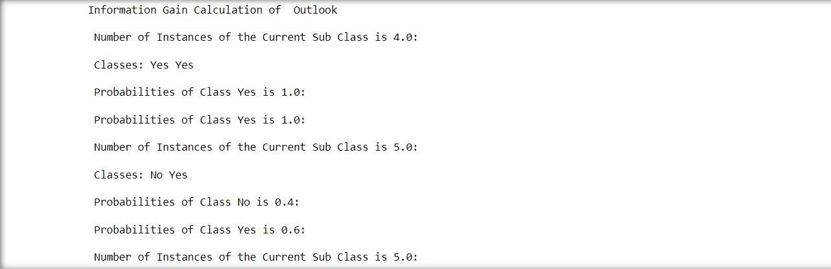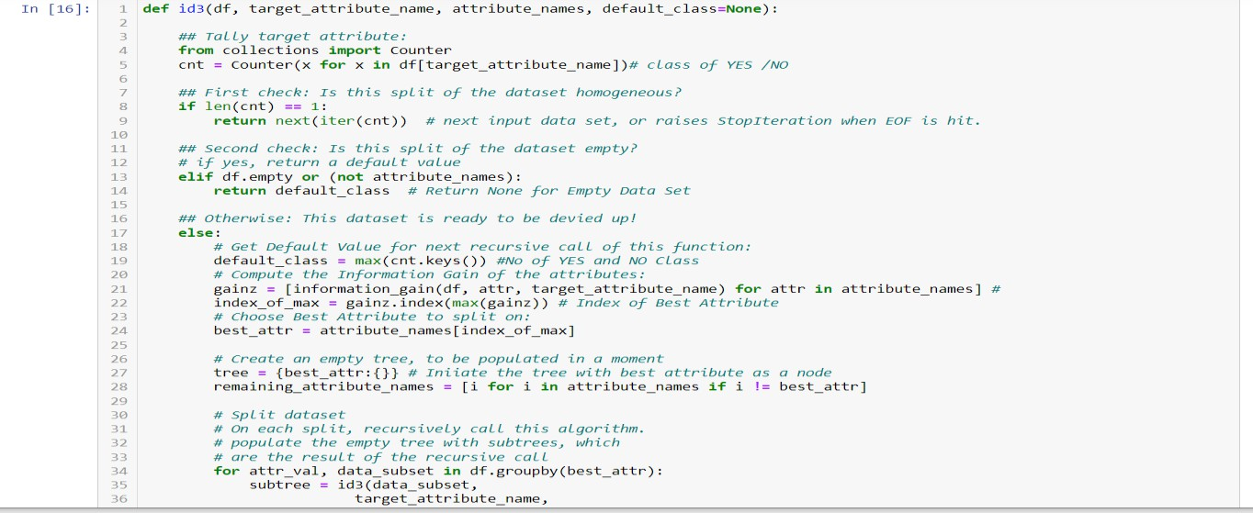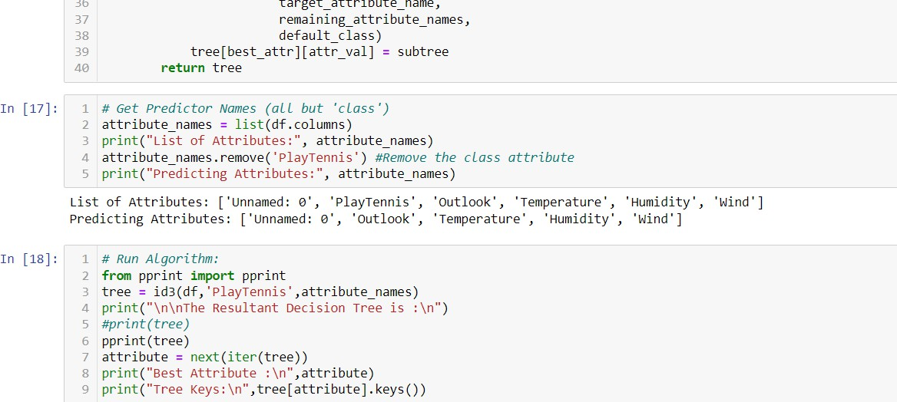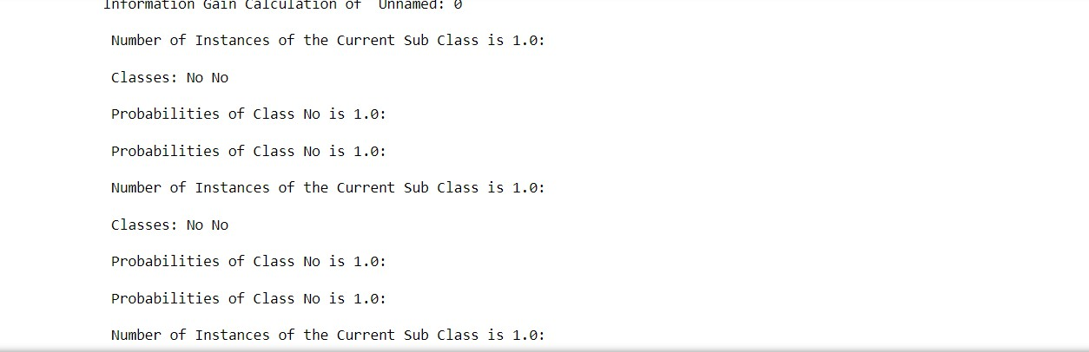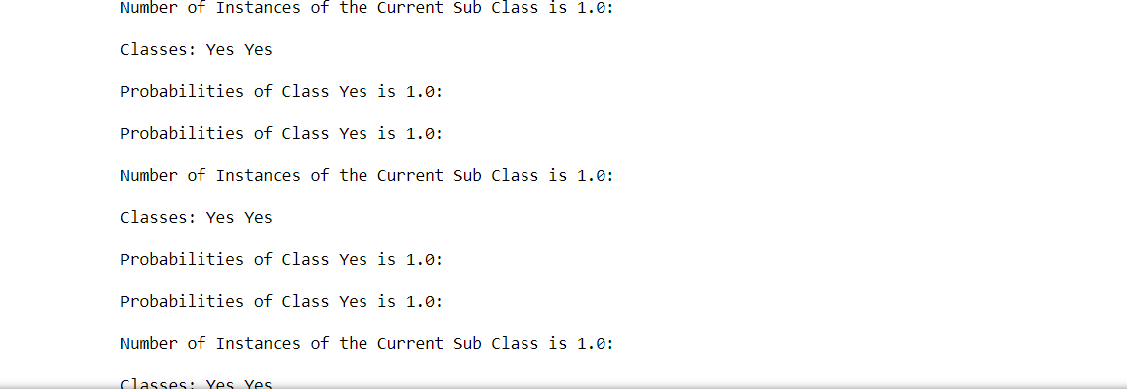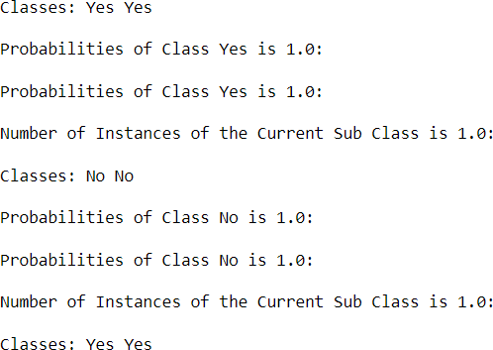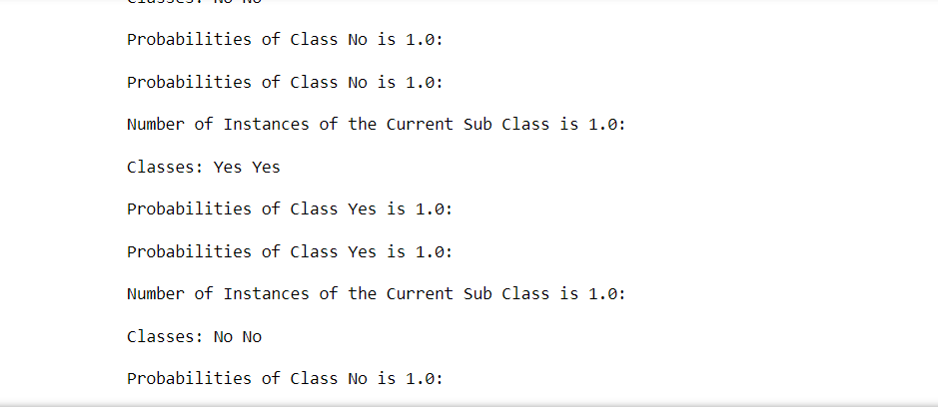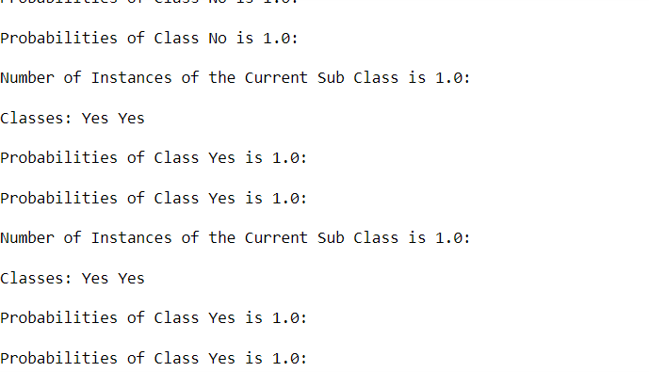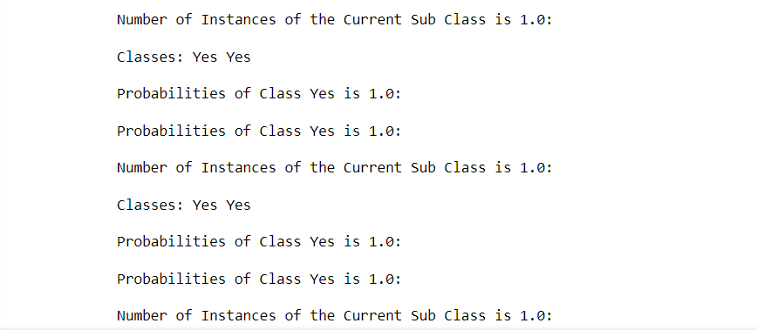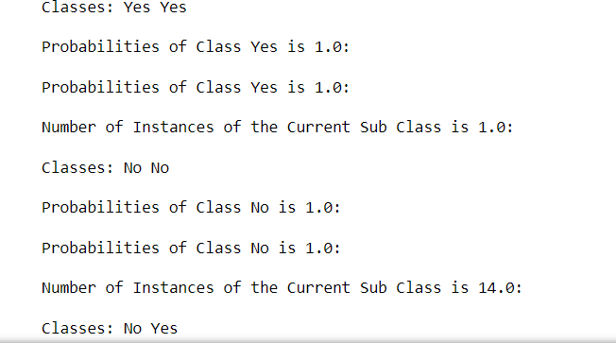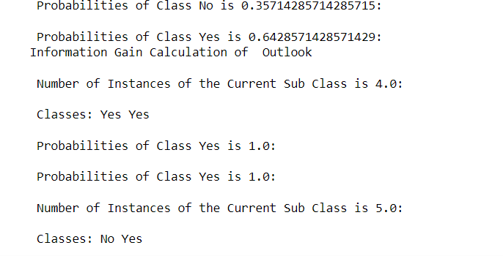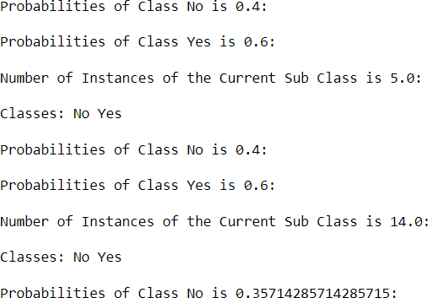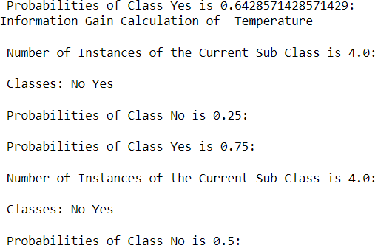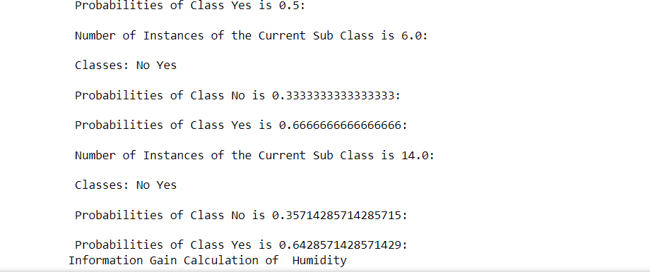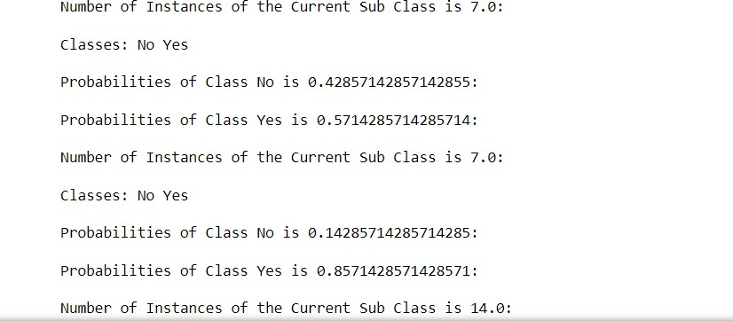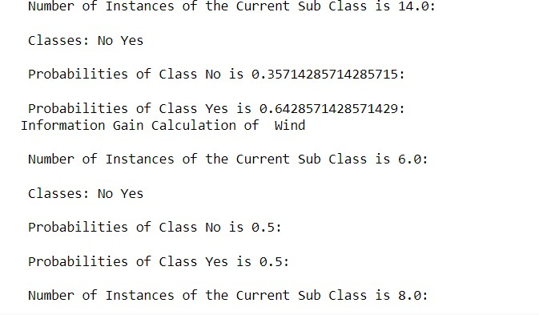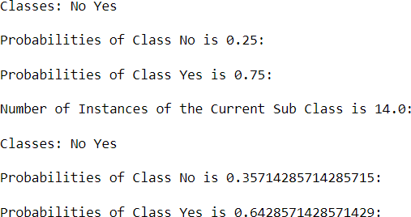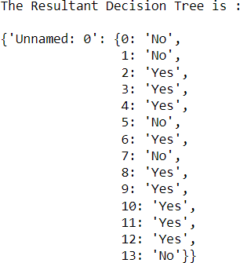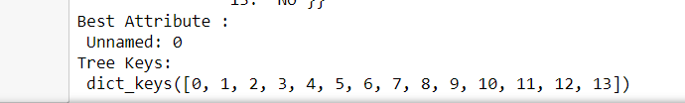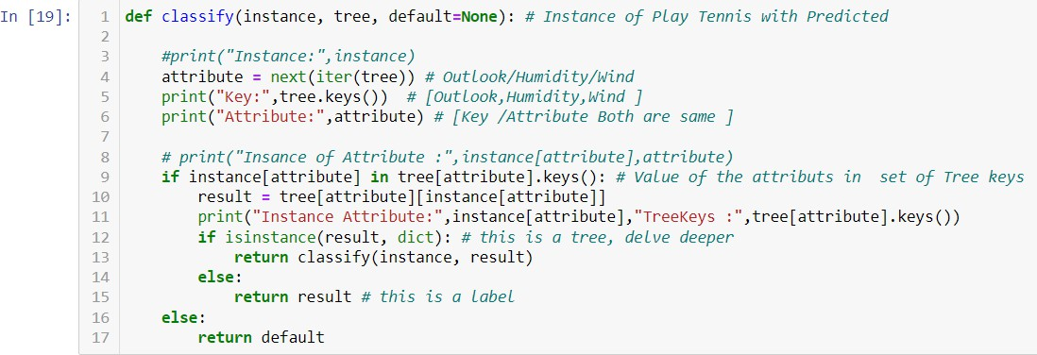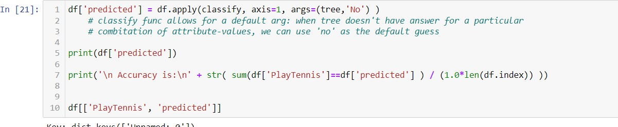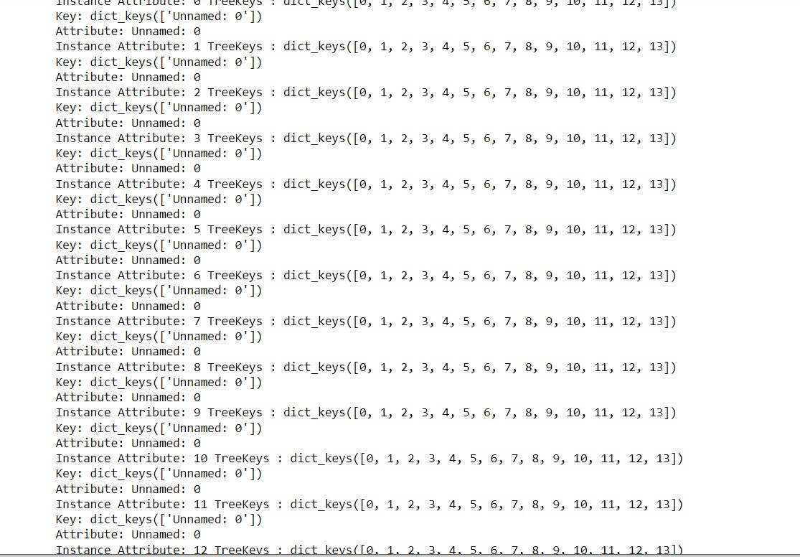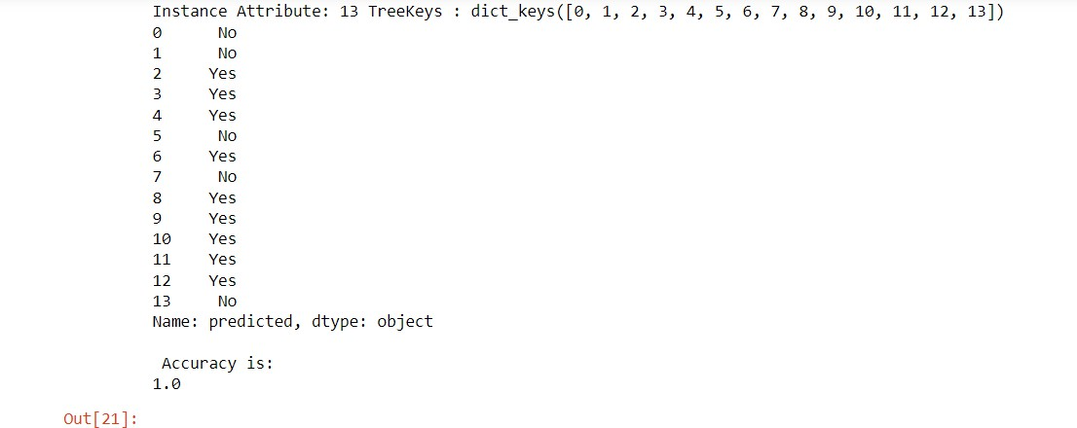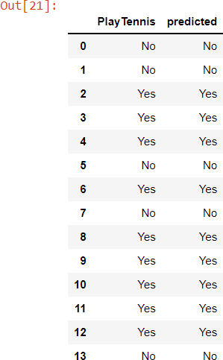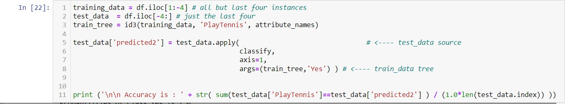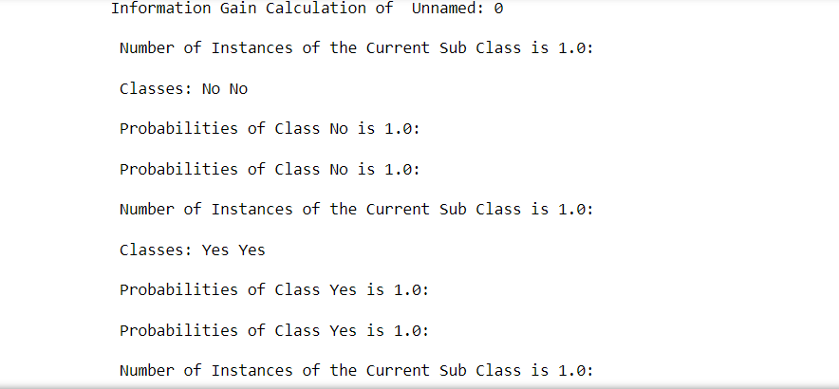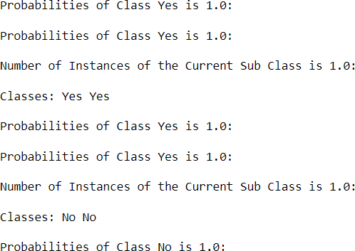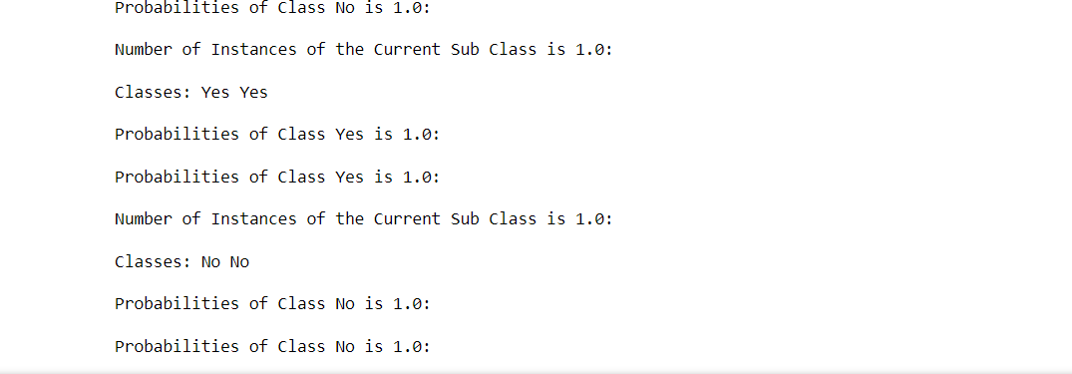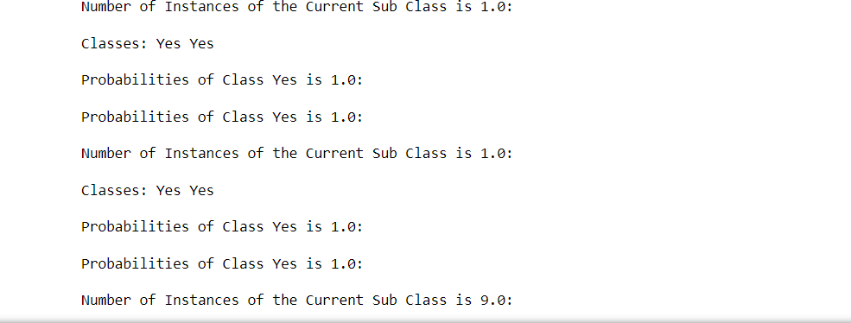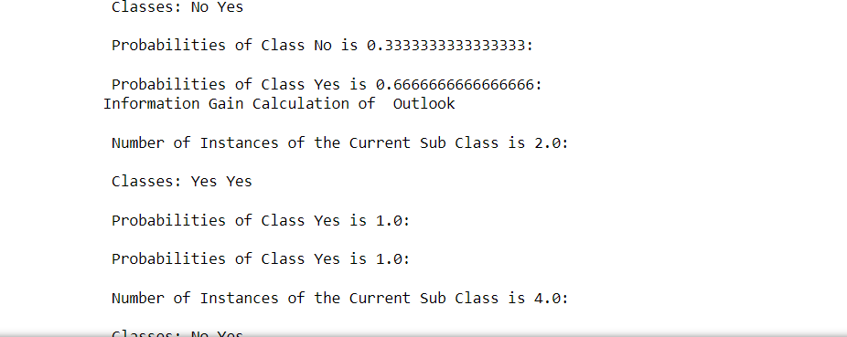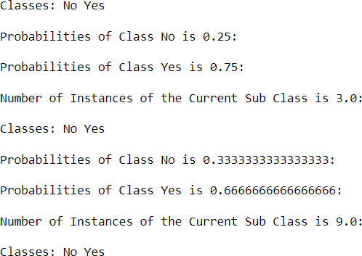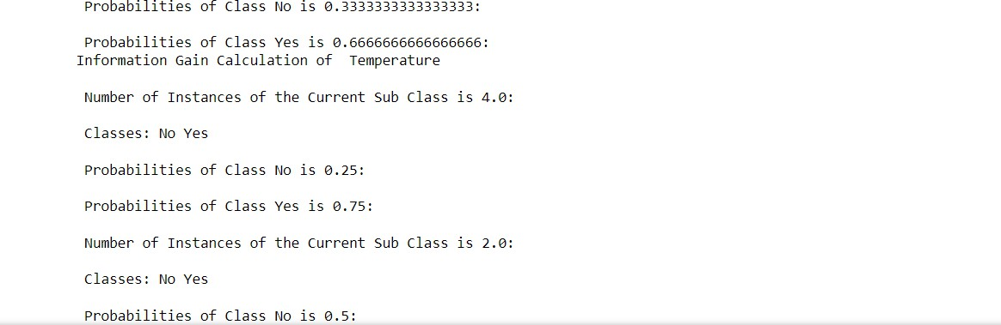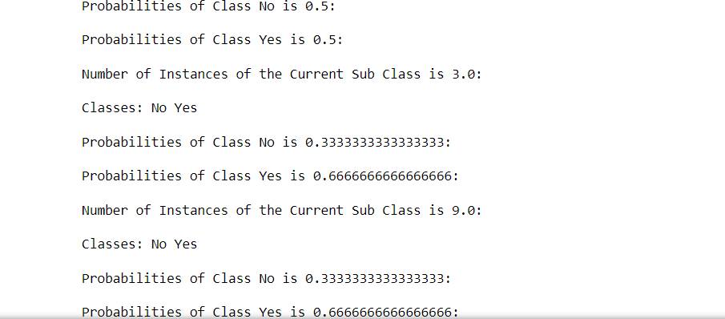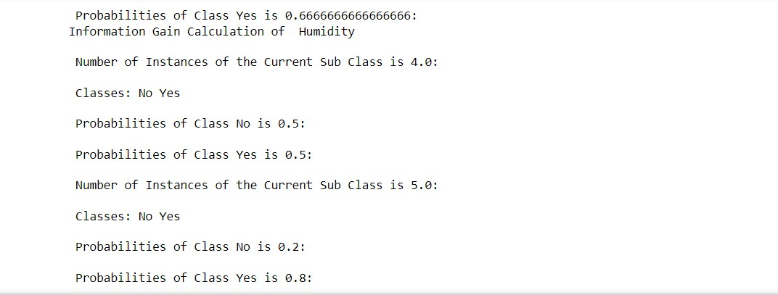

5 b Write a program to implement k-Nearest Neighbour algorithm to classify the iris data set

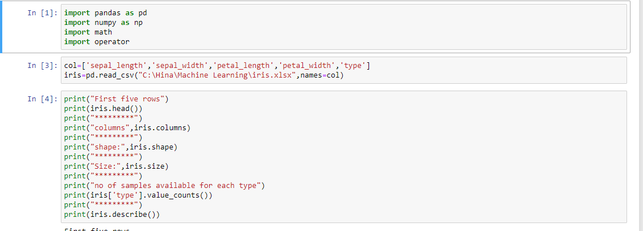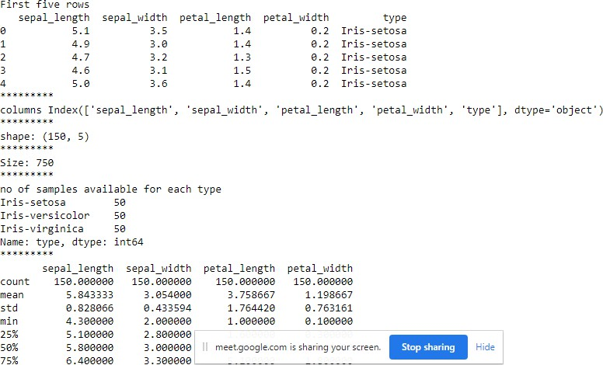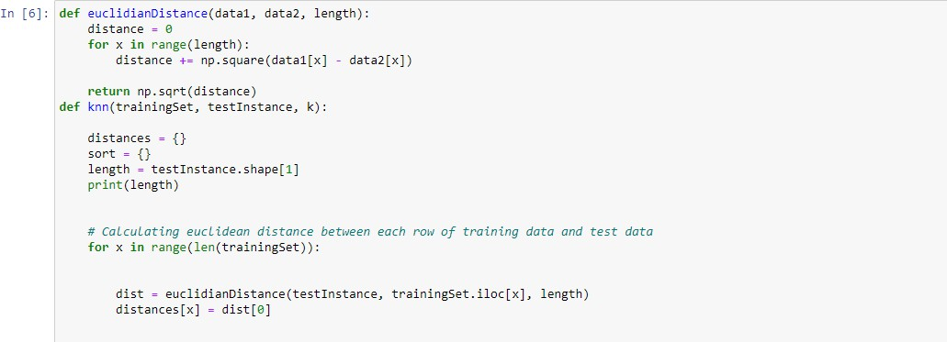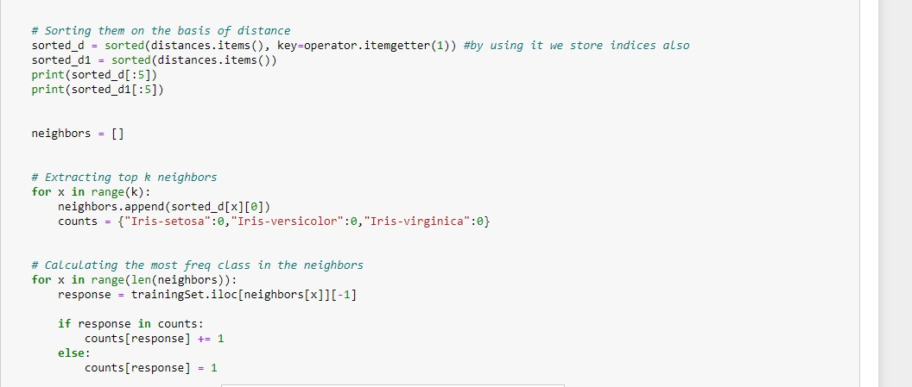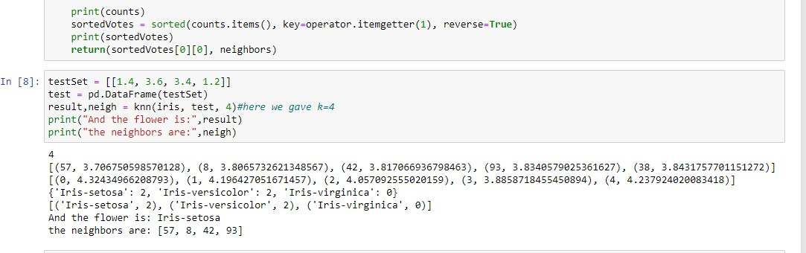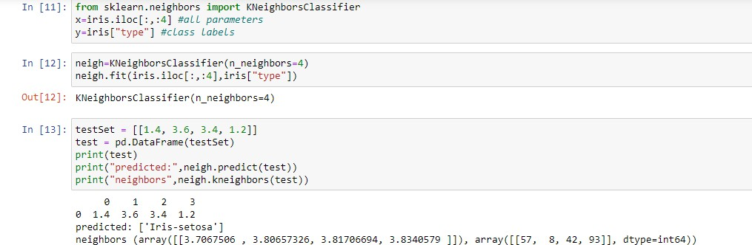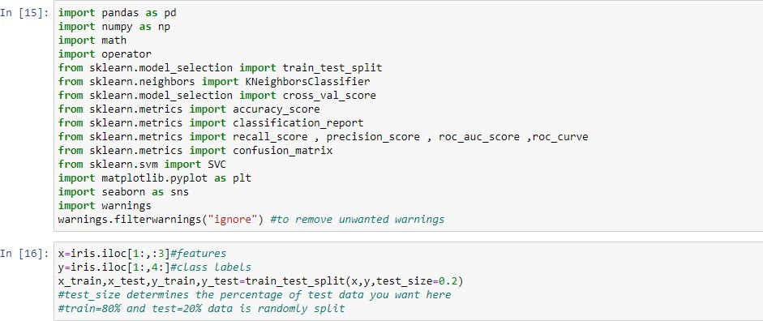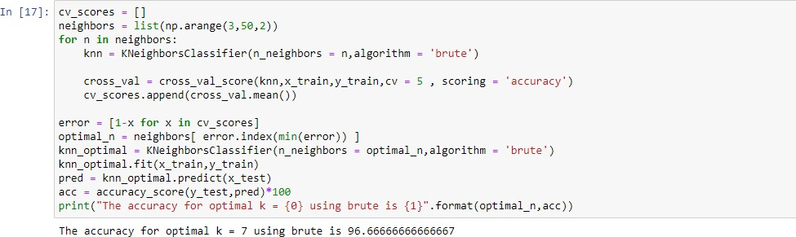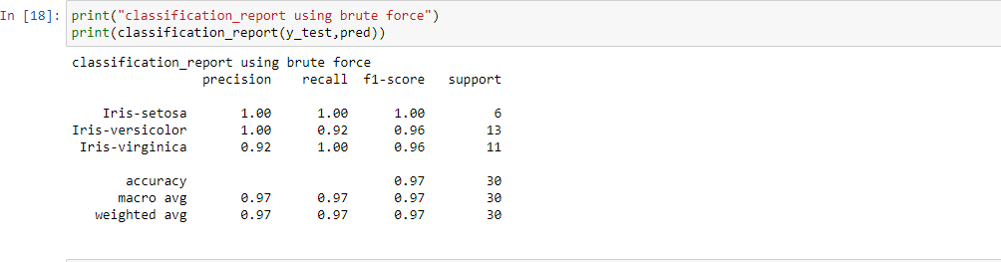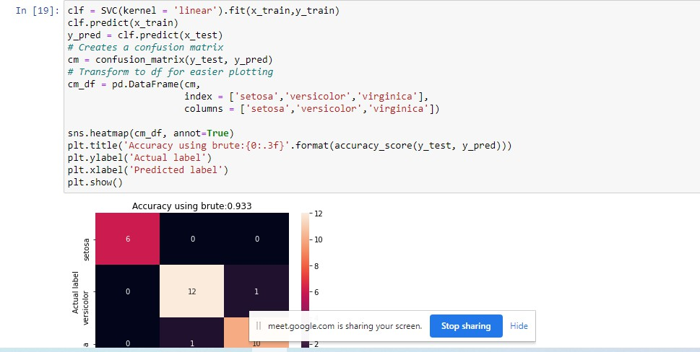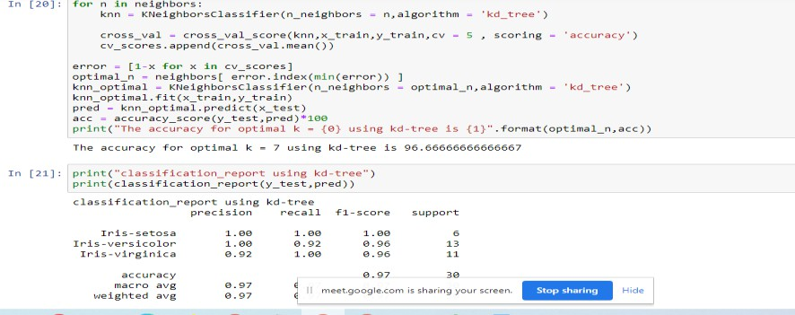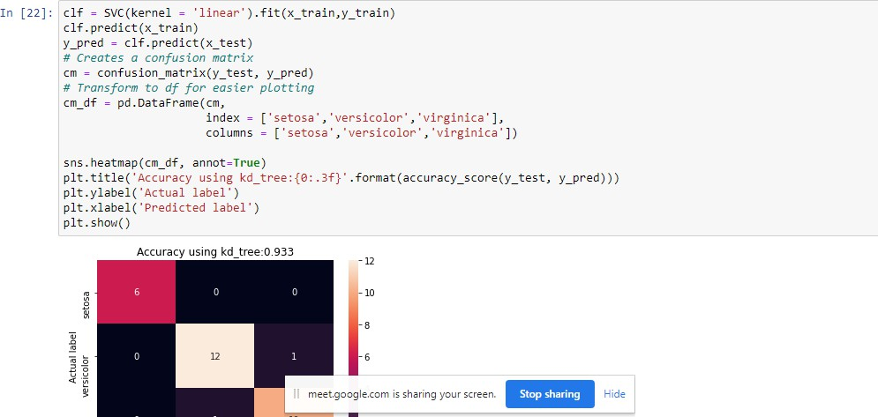

6a Implement the different Distance methods (Euclidean) with Prediction, Test Score and Confusion Matrix

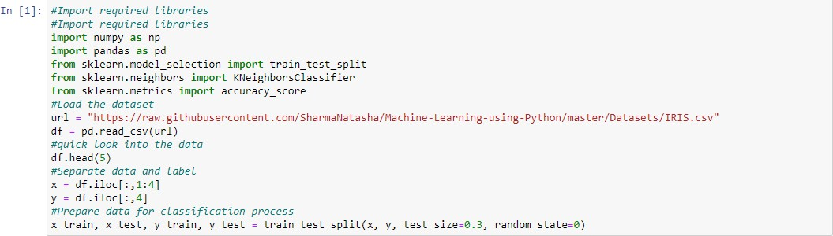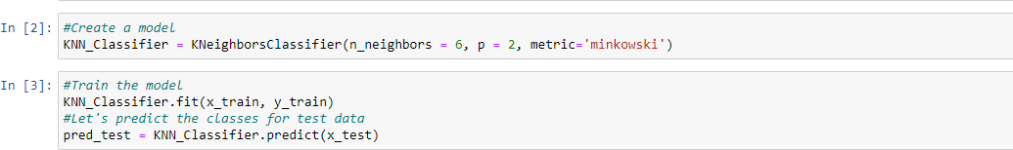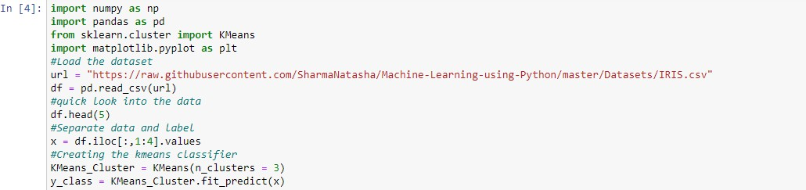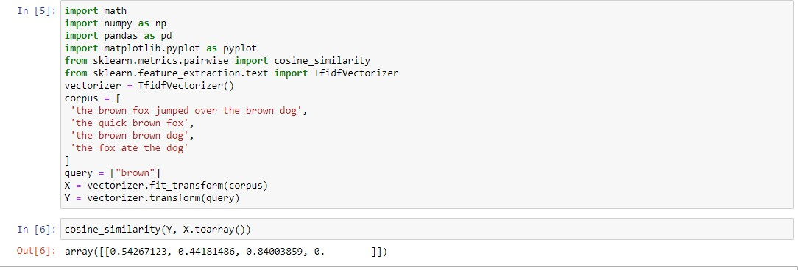

6b Implement the classification model using clustering for the following techniques with K means clustering with Prediction, Test Score and Confusion Matrix.

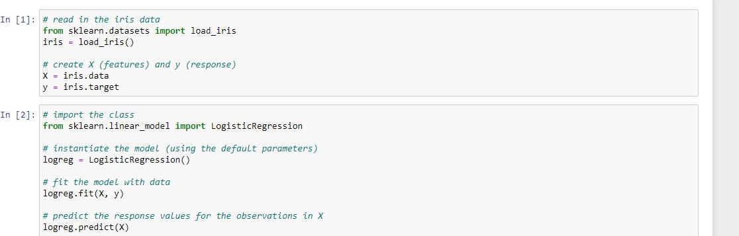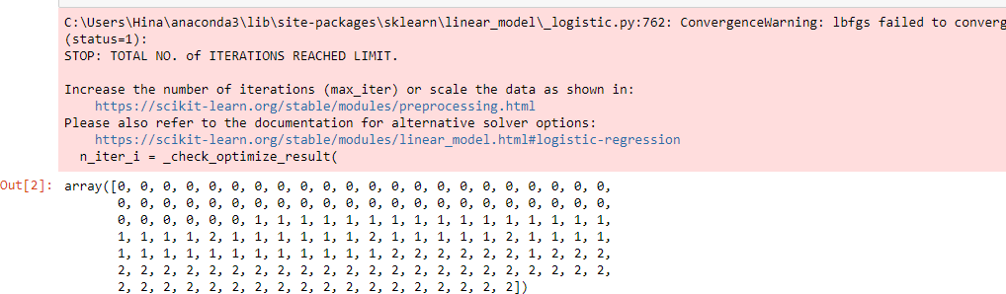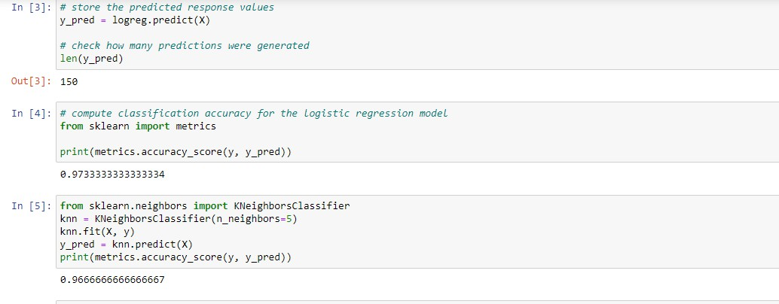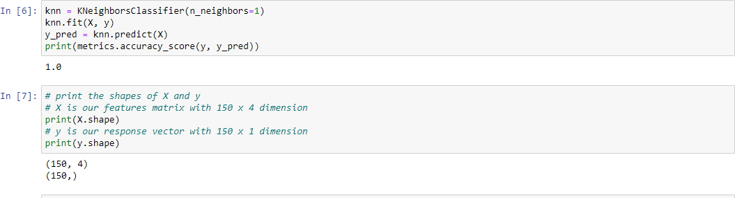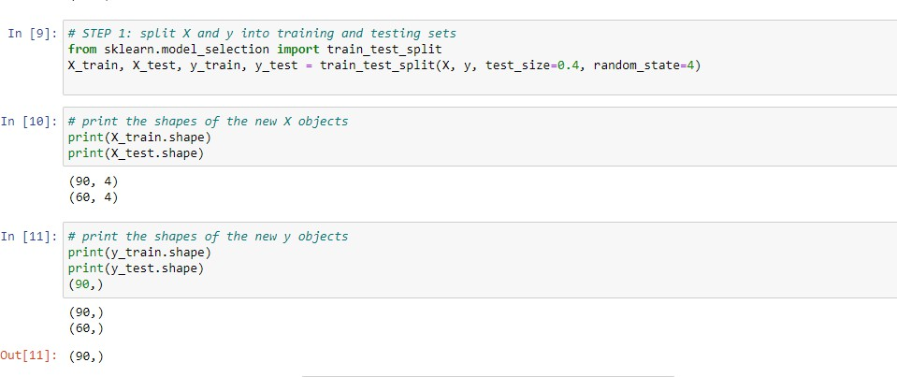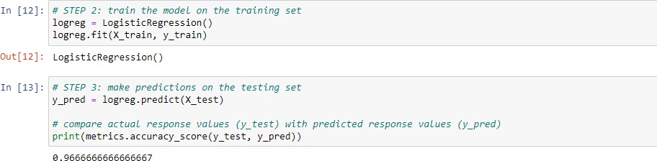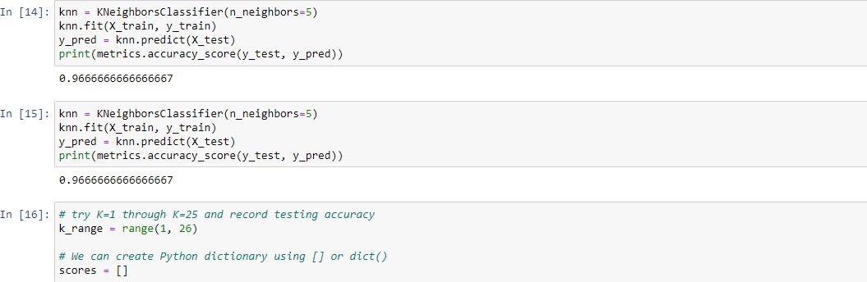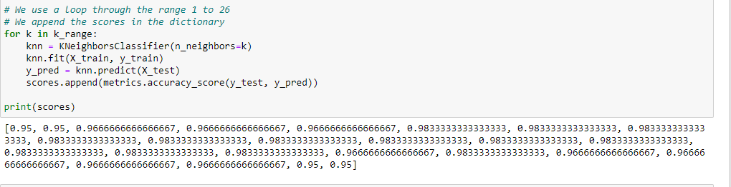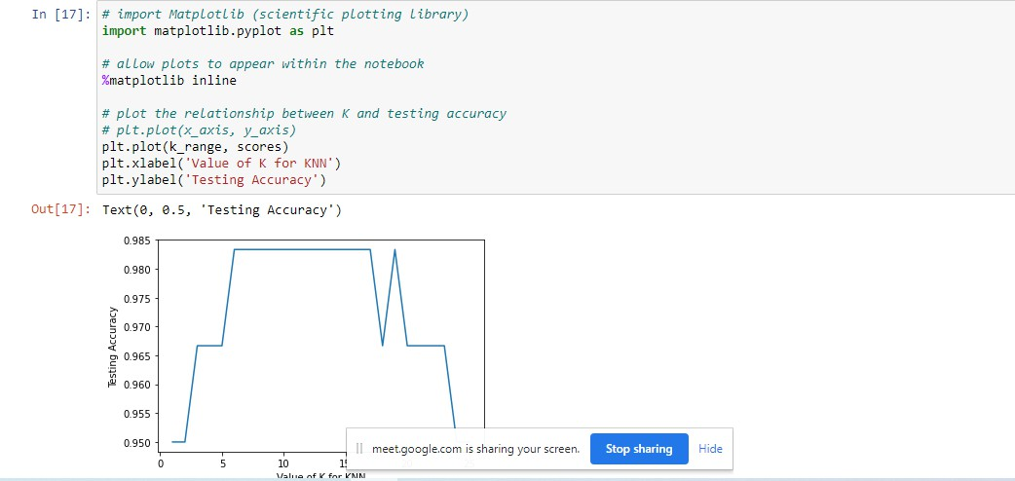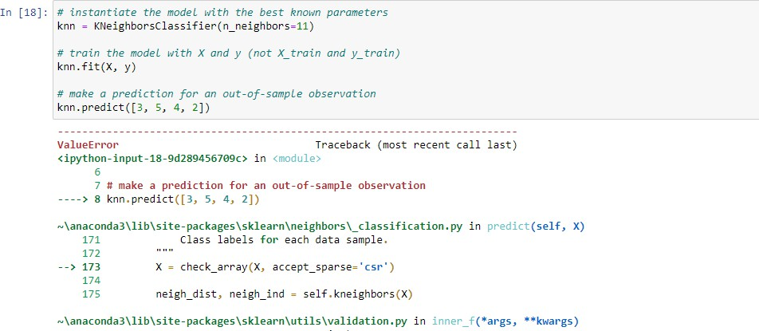

7a Implement the classification model using clustering for the following techniques with hierarchical clustering with Prediction, Test Score and Confusion Matrix

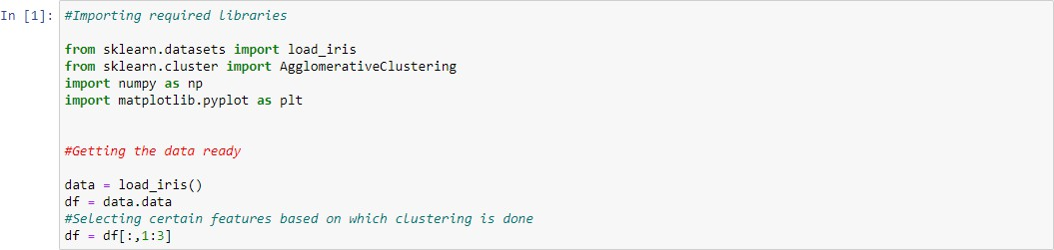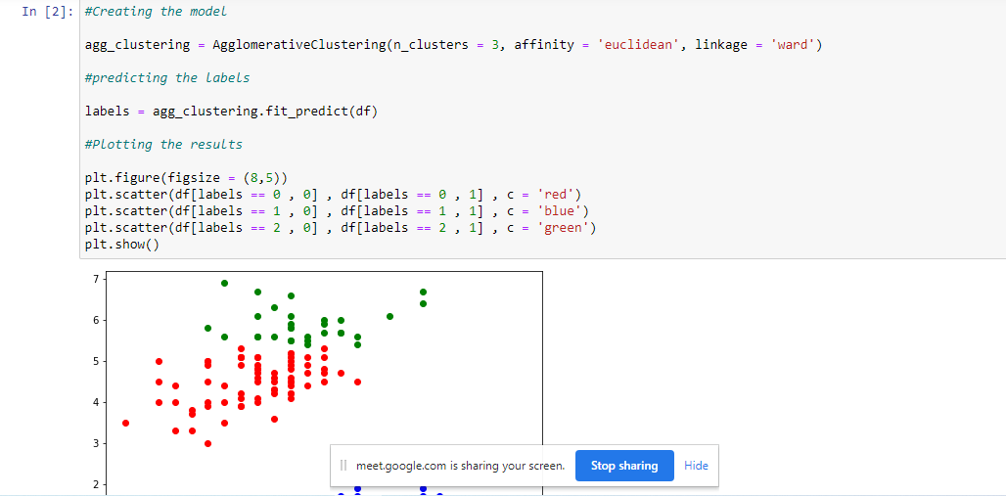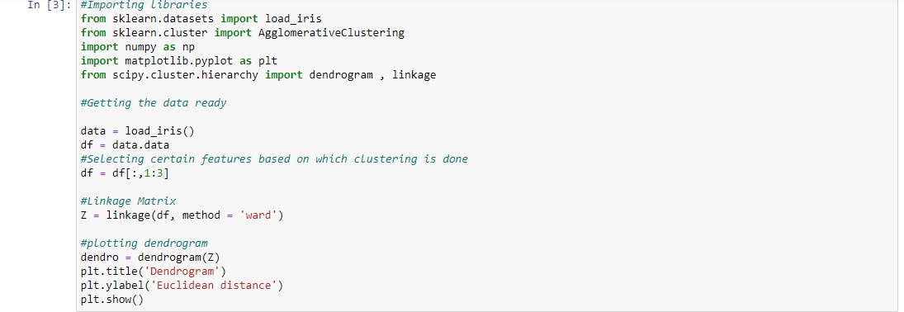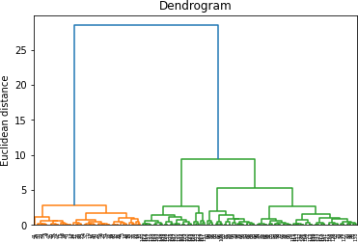

8a. Write a program to construct a Bayesian network considering medical data. Use this model to demonstrate the diagnosis of heart patients using standard Heart Disease Data Set

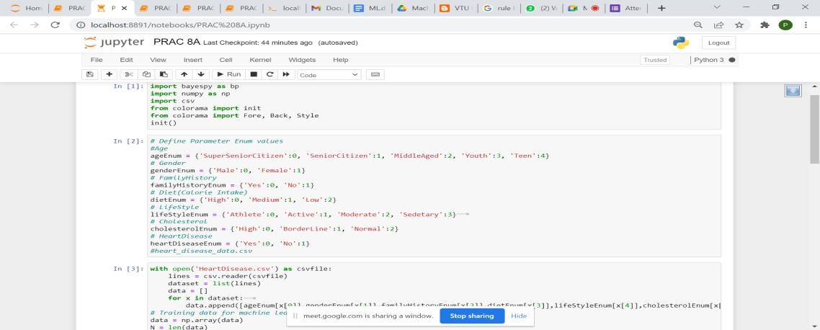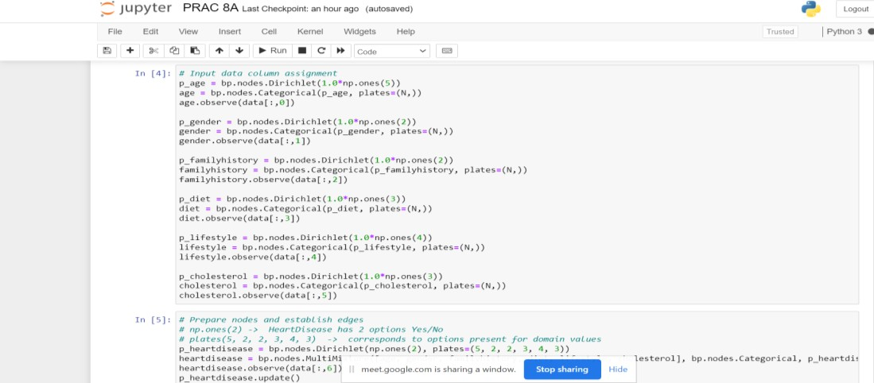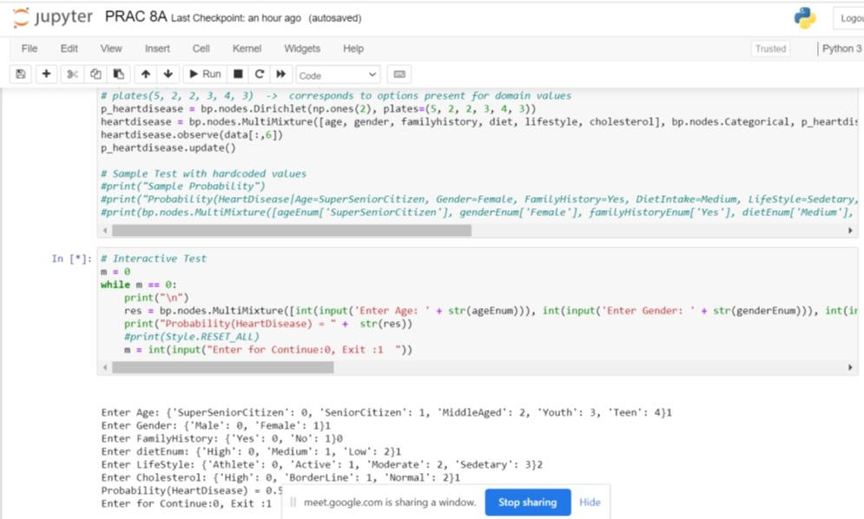

b. Implement the non-parametric Locally Weighted Regression algorithm in order to fit data points. Select appropriate data set for your experiment and draw graphs

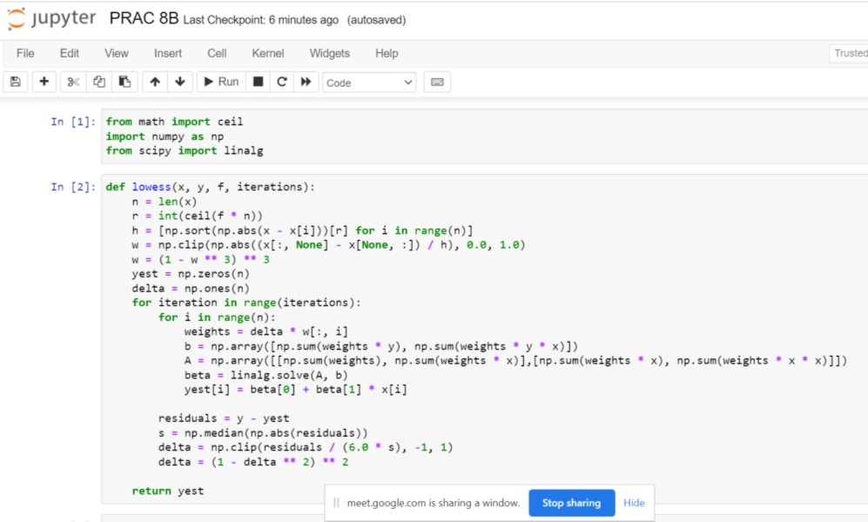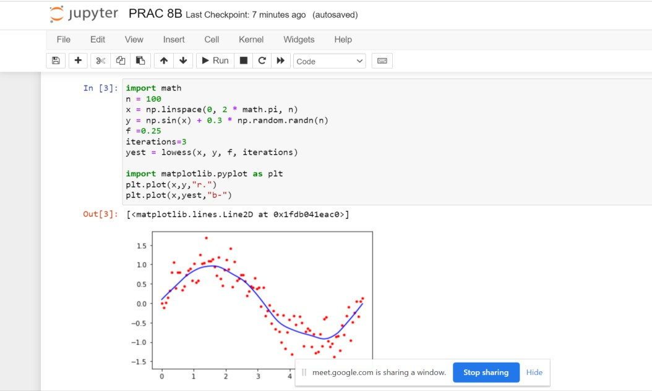

9A. Build an Artificial Neural Network by implementing the Backpropagation algorithm and test the same using appropriate data sets.

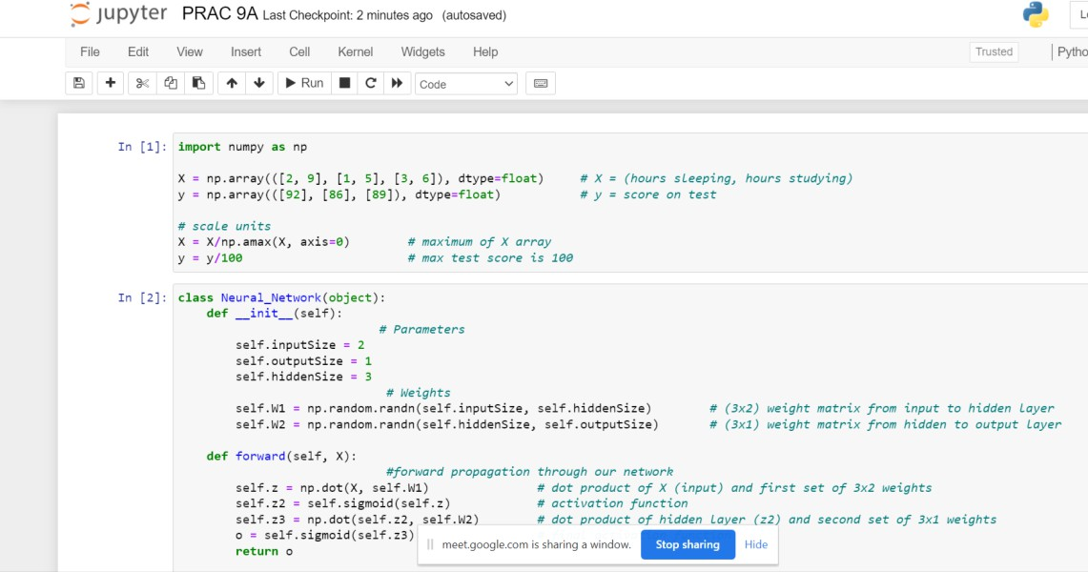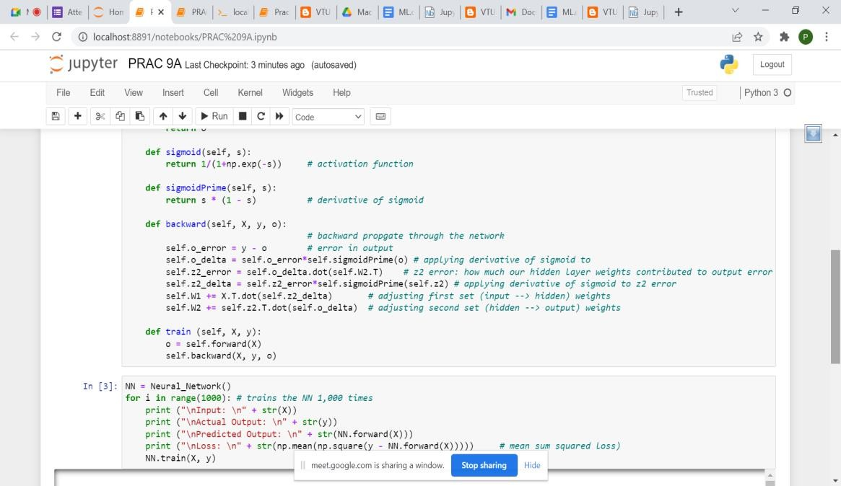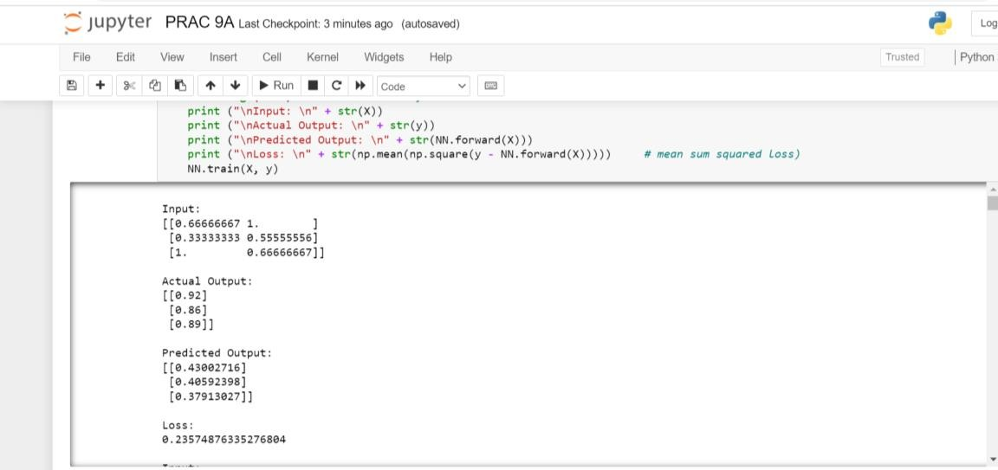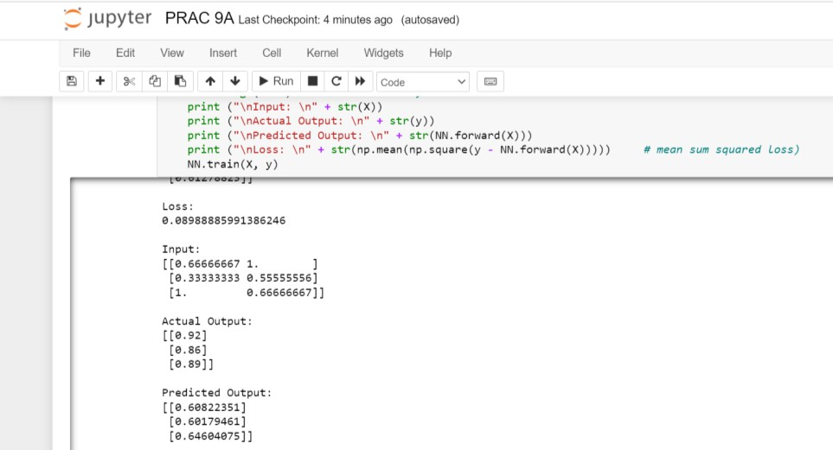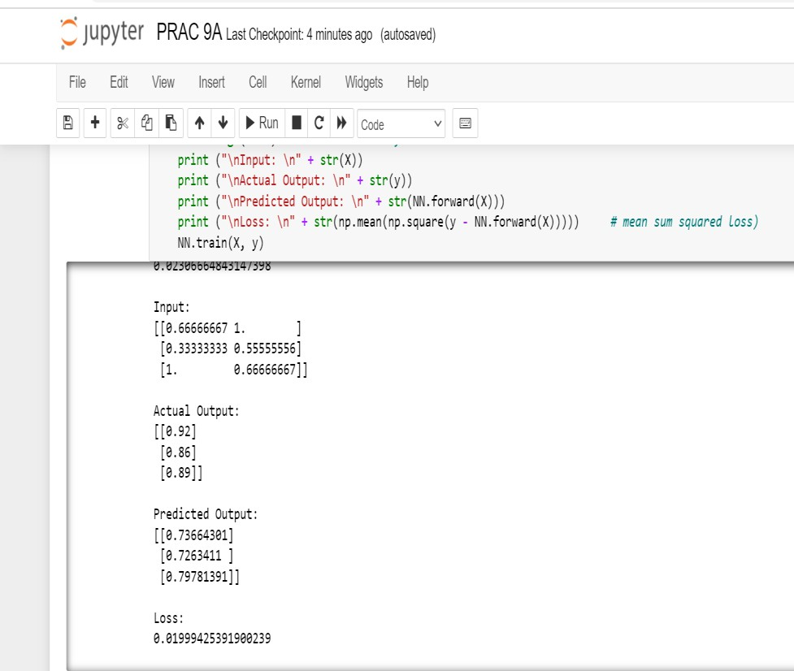

9B. ASSUMING A SET OF DOCUMENTS THAT NEED TO BE CLASSIFIED, USE THE NAÏVE BAYESIAN CLASSIFIER MODEL TO PERFORM THIS TASK. BUILT-IN JAVA CLASSES/API CAN BE USED TO WRITE THE PROGRAM. CALCULATE THE ACCURACY, PRECISION, AND RECALL FOR YOUR DATA SET.

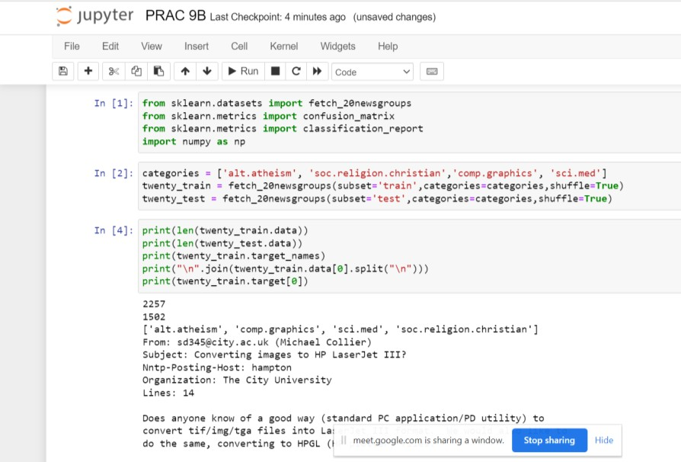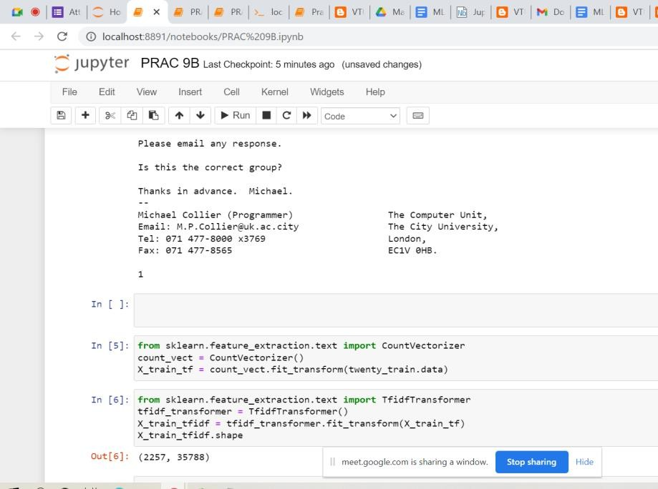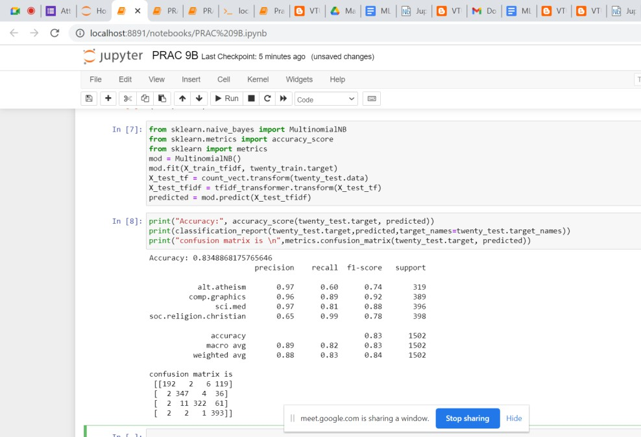

10A . Write a program to demonstrate the working of the decision tree based ID3 algorithm. Use an appropriate data set for building the decision tree and apply this knowledge to classify a new sample.

